**Group Project Documentation   
Advanced Cross-Platform Application Programming with .NET**

***Jewelry Sales System***

**Prepared by No Name**

***Bùi Hiểu Khang***

***Trần Dương Thảo Uyên***

***Trần Thị Kim Ngân***

***Trần Vũ Gia Bảo***

***Đỗ Hữu Thuận***

**Ho Chi Minh City, 2024**

**Table of Contents**

**1. Project Introduction 1**

1.1 Product Perspective 1

1.2 User Classes and Characteristics 1

**2. Database Design 2**

**3. System Architecture 3**

**4. Implementation 3**

4.1. Screenshots and explanations 3

**Revision History**

|  |  |  |  |
| --- | --- | --- | --- |
| **Name** | **Date** | **Reason For Changes** | **Version** |
|  |  |  |  |
|  |  |  |  |
|  |  |  |  |
|  |  |  |  |
|  |  |  |  |
|  |  |  |  |
|  |  |  |  |

# **Project Introduction**

## **Product Perspective**

The Jewelry Sales System at Store is designed to streamline the sales, inventory management, customer relationship, and administrative tasks within a jewelry retail environment. This system aims to enhance the efficiency and accuracy of store operations, provide a better shopping experience for customers, and support decision-making processes for store managers and staff.

## **User Classes and Characteristics**

* Staff :

|  |  |  |
| --- | --- | --- |
|  | **Function Name** | **Function Description** |
| 1 | Login (By Authentication) | Allows staff to securely access the system by entering their credentials. |
| 2 | Create orders | Enables staff to create new orders for customers, including selecting products, quantities, and customer details. |
| 3 | Print invoice + Warranty card | Facilitates the printing of invoices and warranty cards for completed orders, providing customers with proof of purchase and warranty information. |
| 4 | Search for orders | Allows staff to search for existing orders using various criteria such as order number, customer name. |
| 5 | Check sold jewelry information | Provides detailed information about products that have been sold, including product specifications, sale date, and customer details. |
| 6 | Buy back goods at preferential prices | Enables staff to process the buyback of goods from customers at preferential prices, typically as part of a return or exchange policy. |
| 7 | Search for buyback orders | Allows staff to search for and review buyback orders using various criteria such as order number, customer name, or date. |
| 8 | Issue bills to customers | Facilitates the creation and issuance of bills to customers for their purchases, including calculating totals and applying any discounts. |
| 9 | See list of discounted guests | Provides a list of customers who are eligible for discounts, including details of the discounts they are entitled to. |
| 10 | Confirm discount from manager (Manager) | Allows managers to review and confirm discount requests submitted by staff, ensuring that discounts are applied correctly and appropriately. |

* Manager :

|  |  |  |
| --- | --- | --- |
|  | **Function Name** | **Function Description** |
| 1 | Create promotions | Develop and configure new promotional campaigns. |
| 2 | Promotional release | Launch and make promotions available to customers. |
| 3 | Update promotions before release | Modify and update promotional details prior to their launch. |
| 4 | Search for promotions | Look up existing promotions in the system. |
| 5 | View promotions (List, Details) | Display a list and detailed view of current promotions. |
| 6 | See list of discounted guests | Access a list of customers who have received discounts. |
| 7 | Confirm discount | Verify and approve discounts given to customers. |
| 8 | View item list and ratings | Display a list of items and their customer ratings. |
| 9 | Assign point levels to customer levels | Allocate points to different customer levels based on criteria. |
| 10 | Statistics on customer score hierarchy | Generate statistical reports on customer score distribution. |
| 11 | Update level level based on money | Adjust customer levels based on their spending. |
| 12 | Set up jewelry returns correctly | Configure and manage the process for jewelry returns. |
| 13 | See the overall range of jewelry in the counter | View the complete inventory of jewelry available. |
| 14 | See details of each type of jewelry | Display detailed information about each type of jewelry. |
| 15 | Search product information | Look up detailed information about products. |
| 16 | Manage jewelry | Oversee and control the inventory and details of jewelry items. |
| 17 | Manage material of jewelry | Handle and manage the materials used in jewelry. |
| 18 | See total types of jewelry materials | Display the total count of different jewelry materials. |
| 19 | Sort jewelry by type | Organize jewelry items based on their type. |

* Administrator:

|  |  |  |
| --- | --- | --- |
|  | **Function Name** | **Function Description** |
| 1 | Login (By Authentication) | Allows users to log into the system by authenticating their login information. |
| 2 | Manage User (CRUD) | Manages users including Create, Read, Update, and Delete operations on user information. |
| 3 | Monitor working status (Off-duty, On-the-job) | Monitors the working status of employees, including off-duty and on-the-job statuses. |
| 4 | Statistics of jewelry quantity | Provides statistics on the quantity of jewelry currently in stock or sold. |
| 5 | Statistics on the number of employees | Provides statistics on the current number of employees in the company. |
| 6 | Statistics on the number of promotions | Provides statistics on the number of promotional campaigns that have taken place or are ongoing. |
| 7 | Statistics on the number of orders repurchased | Provides statistics on the number of orders that have been repurchased by customers. |
| 8 | Statistics on the number of orders per week, month and year | Provides statistics on the number of orders on a weekly, monthly, and yearly basis. |

# **Database Design**

# **System Architecture**

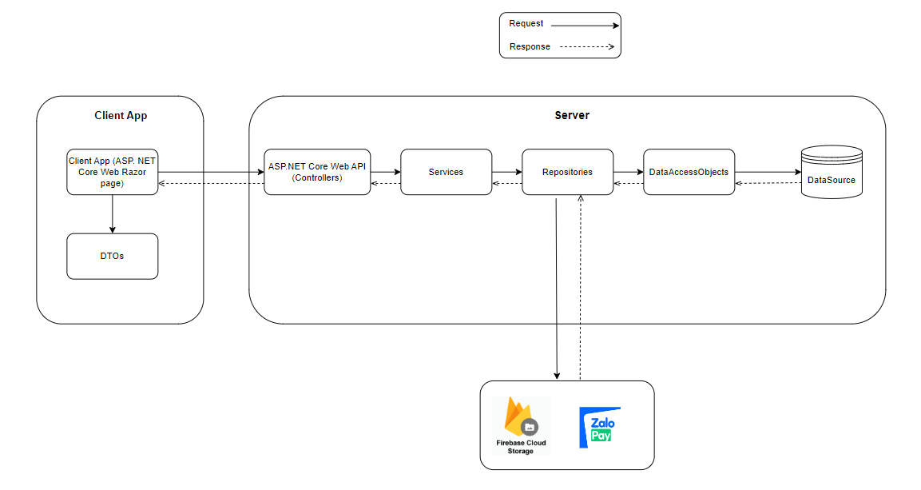

# **Implementation**

## **Screenshots and explanations**

1. Login

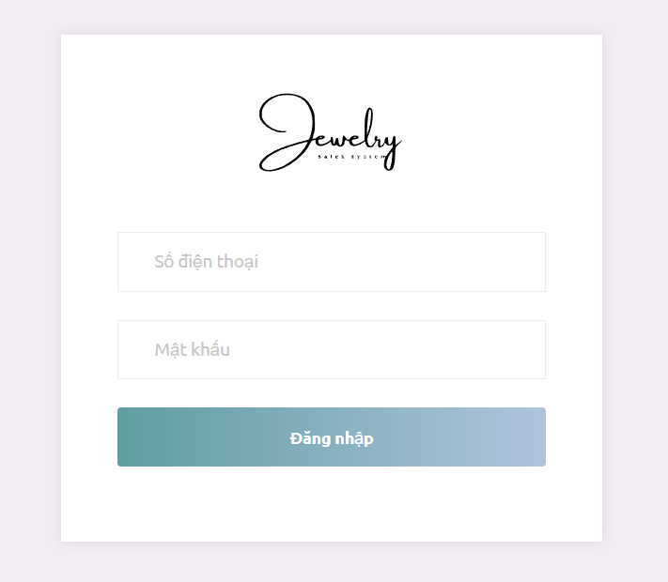

1. Logout:

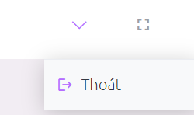

1. Manage Profile

3.1 View profile

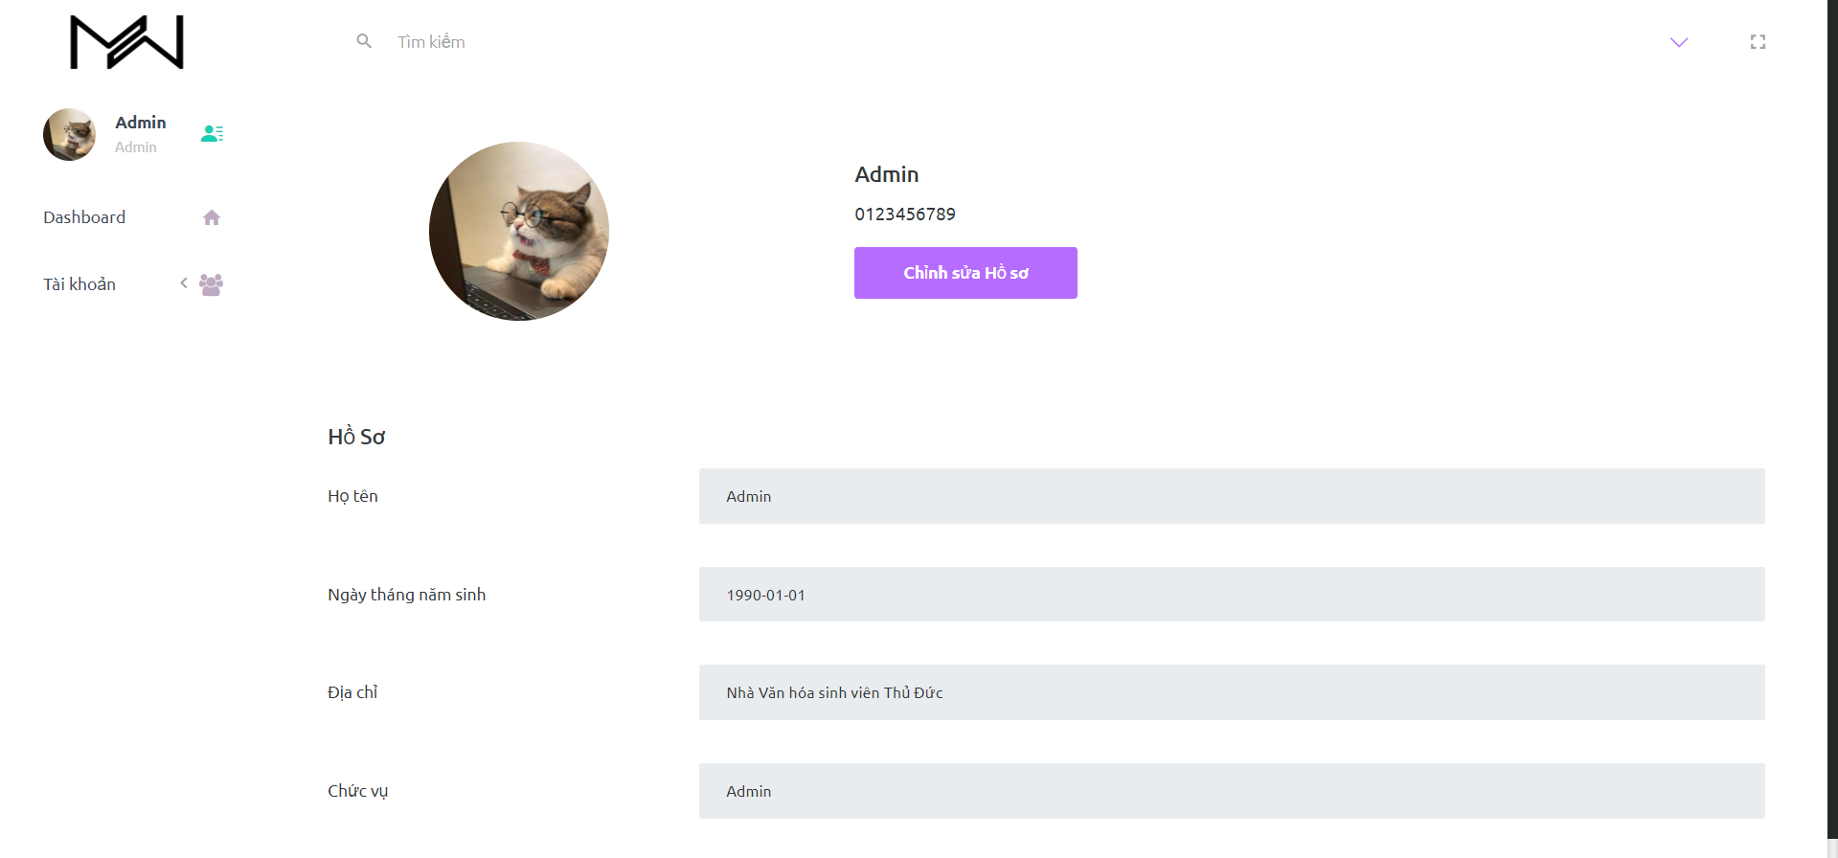

3.2 Edit profile

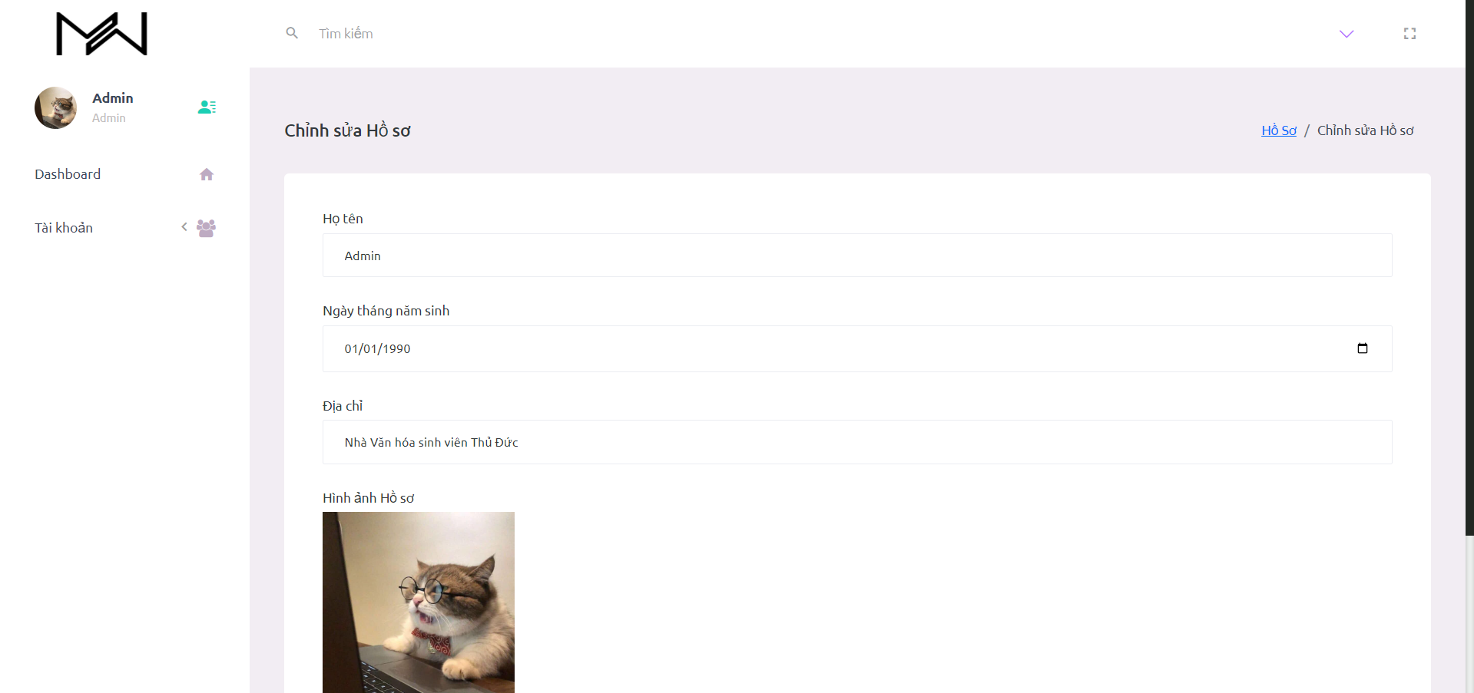

1. Manage Account

4.1 View list account

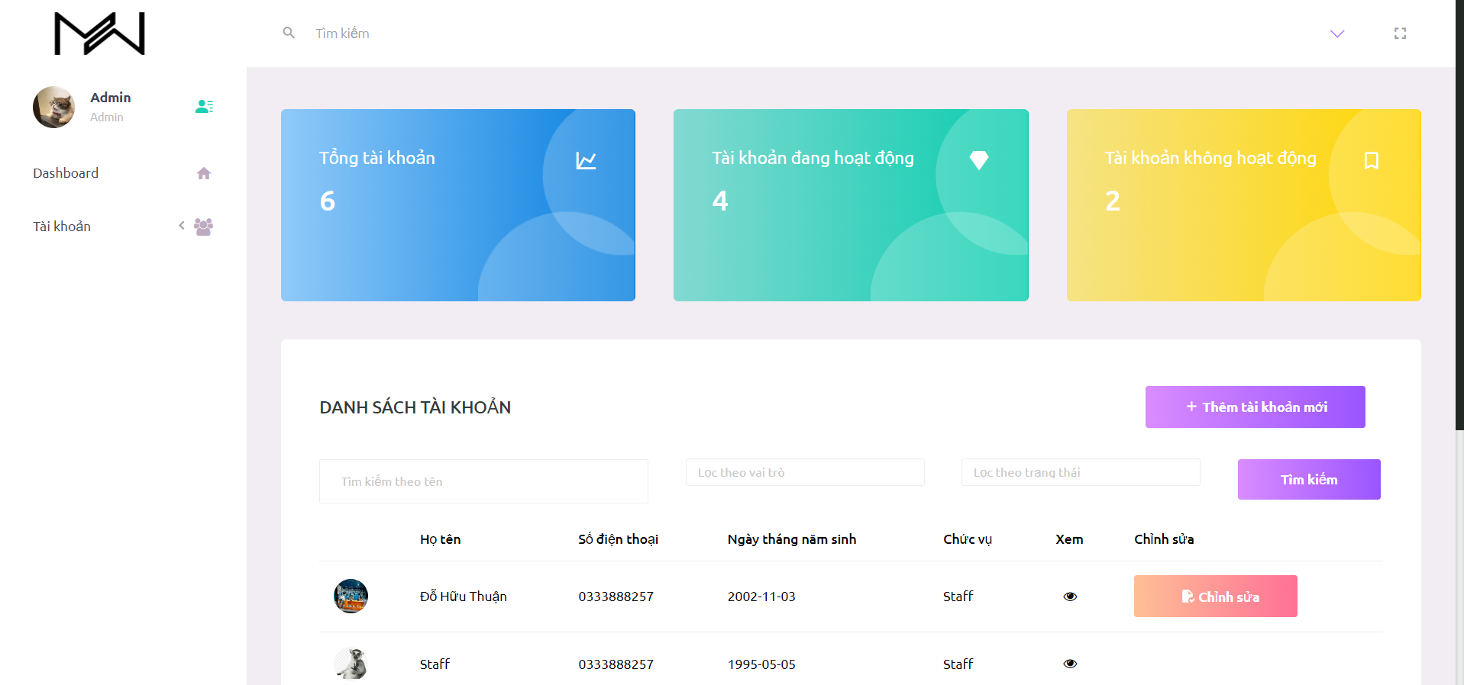

4.2 Static and Search Filter account

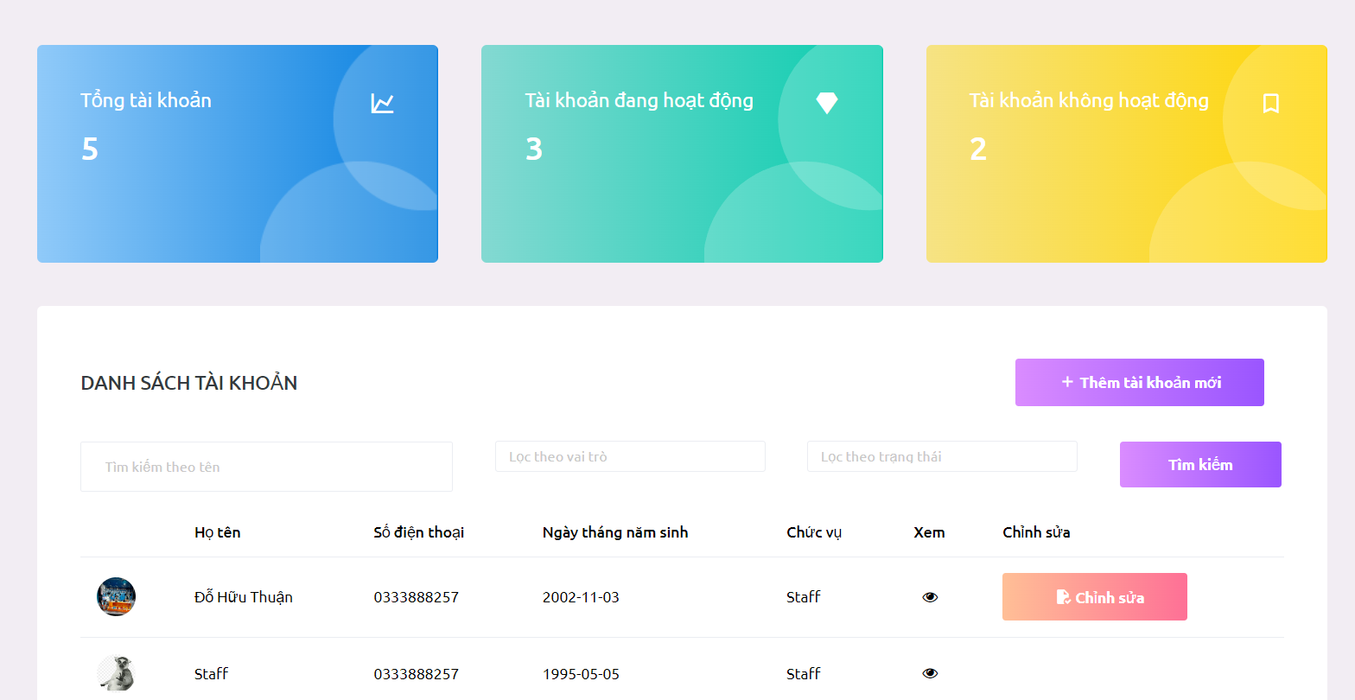

4.3 Create a new account

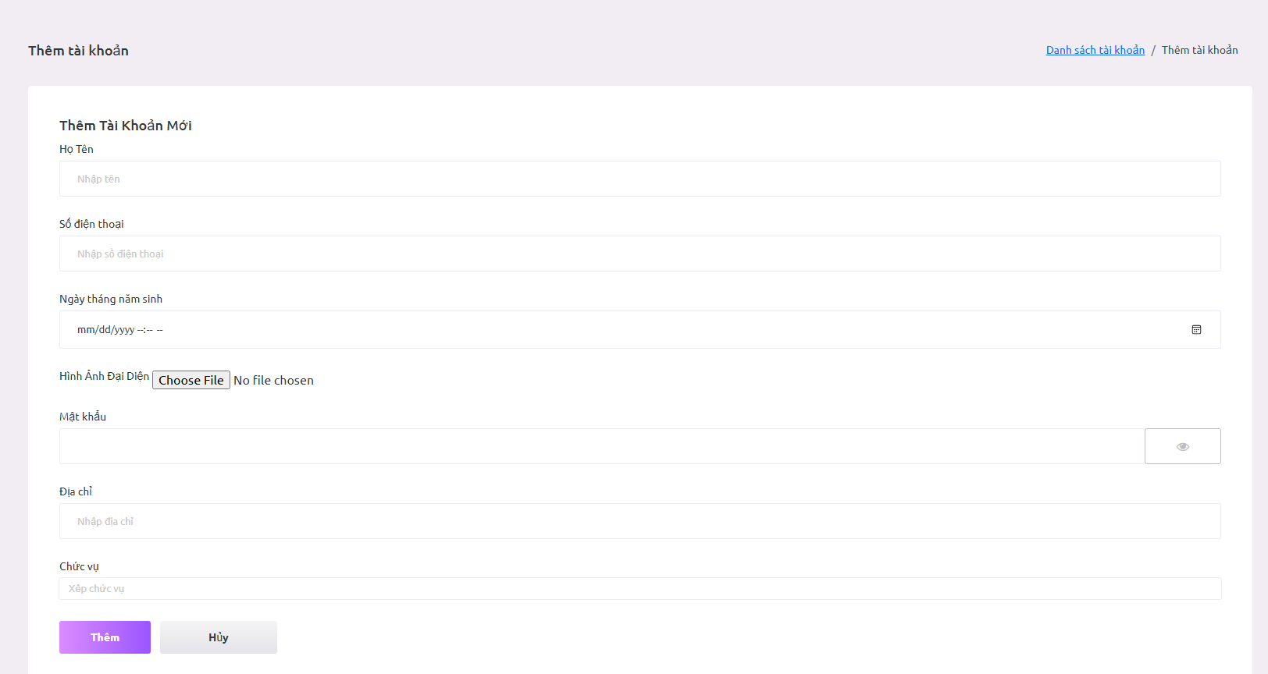

4.4 Edit account

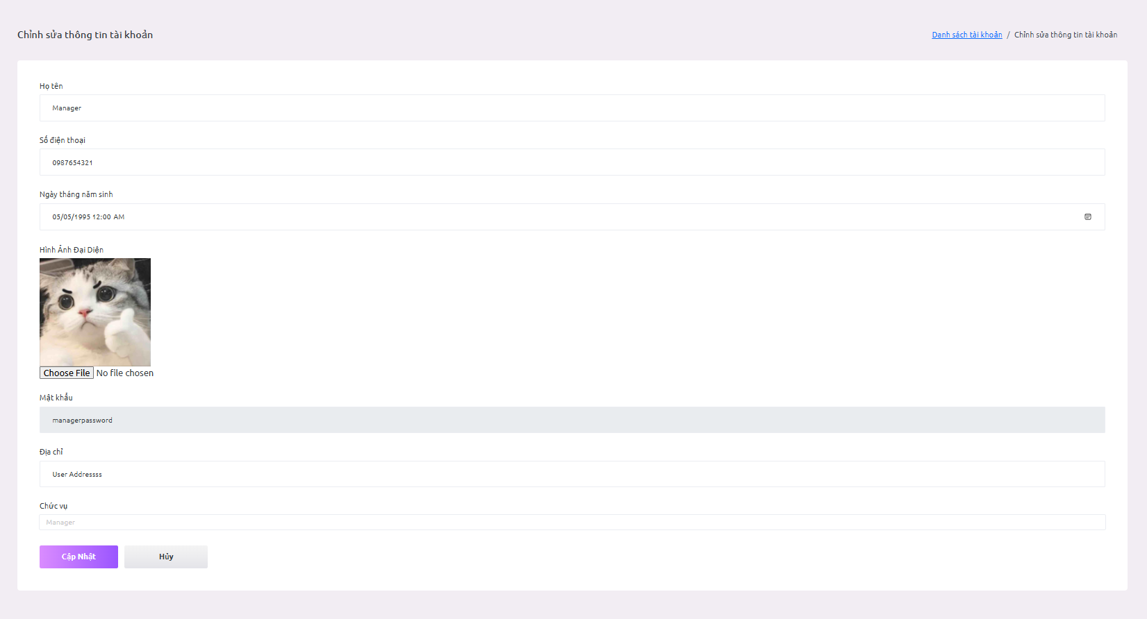

4.5 Detail account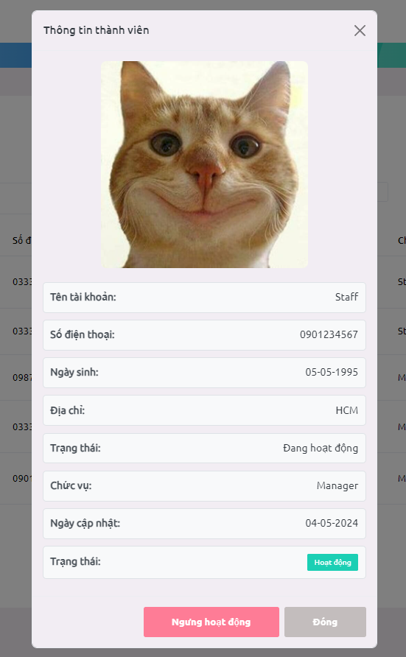

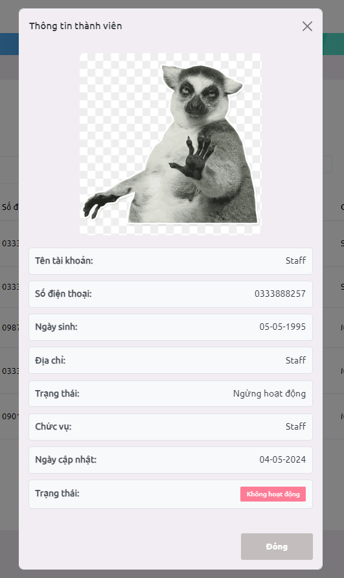

5. Manage Jewelry

5.1. View list jewelry

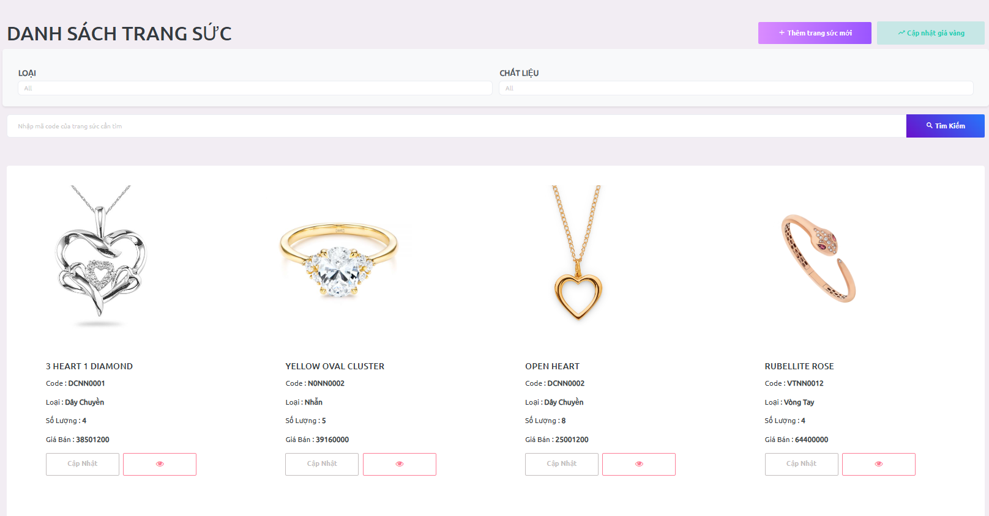

5.2. Search and Filter jewelry

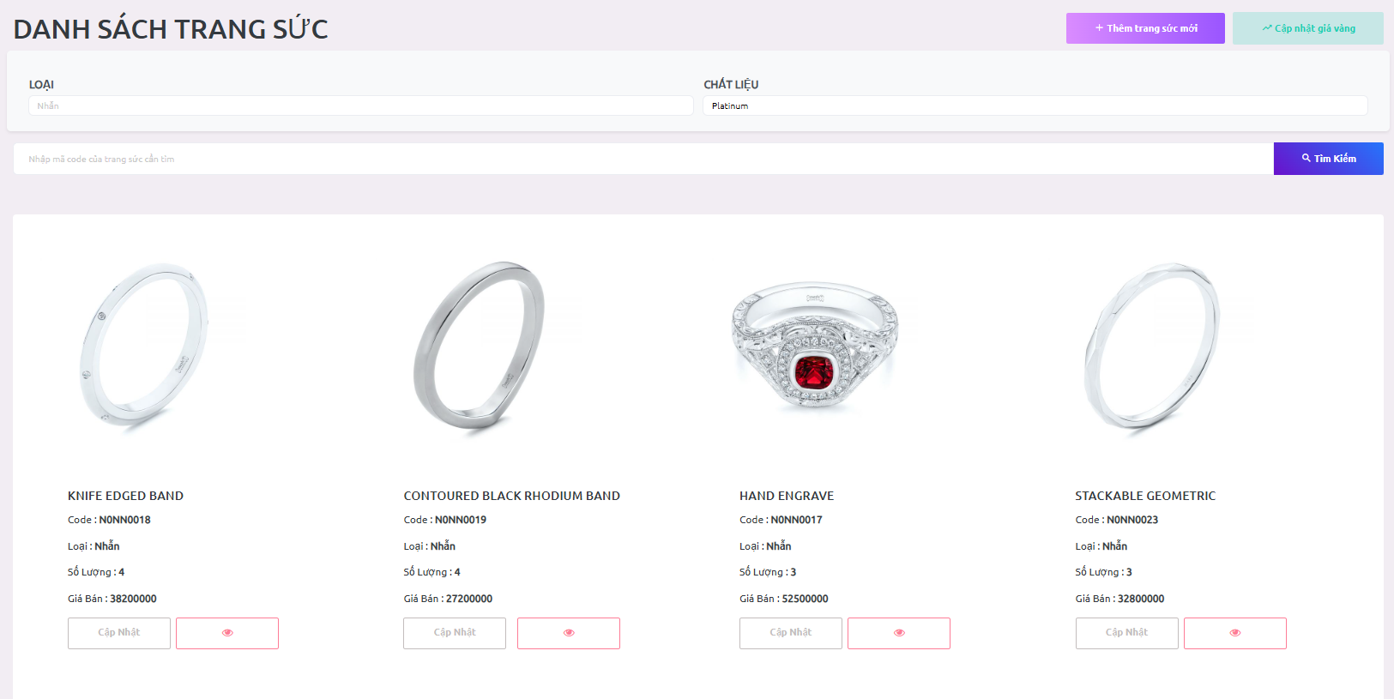

5.3. Create a new jewelry

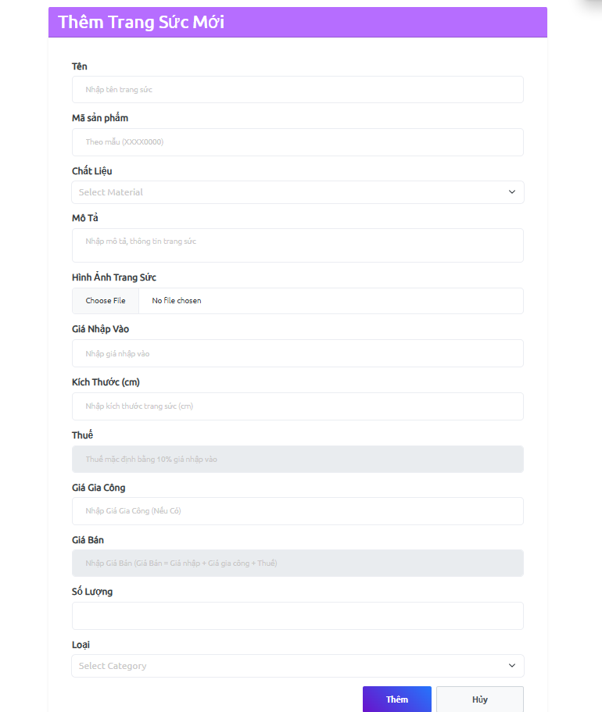

5.4. Edit jewelry

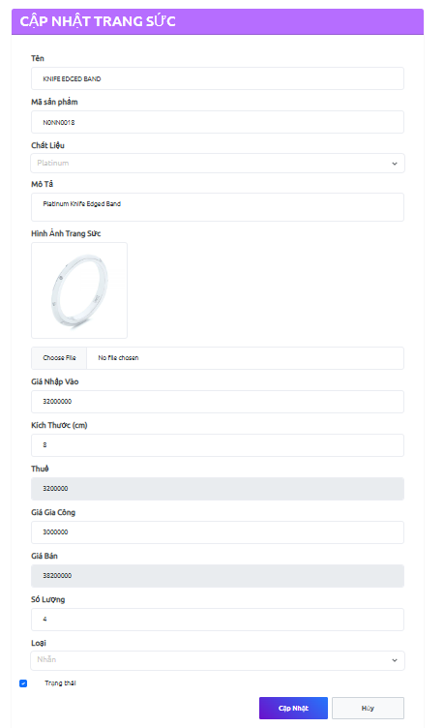

5.5. Update Gold Rate

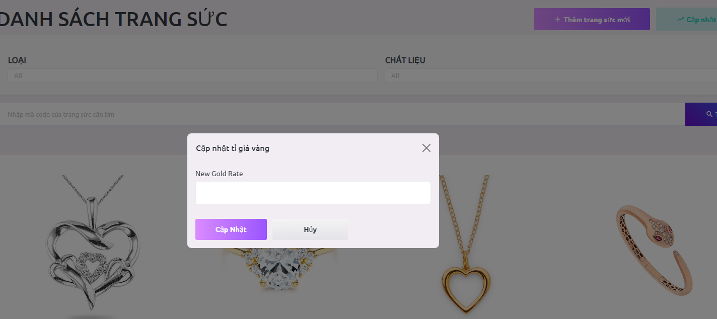

5.6. Details Jewelry

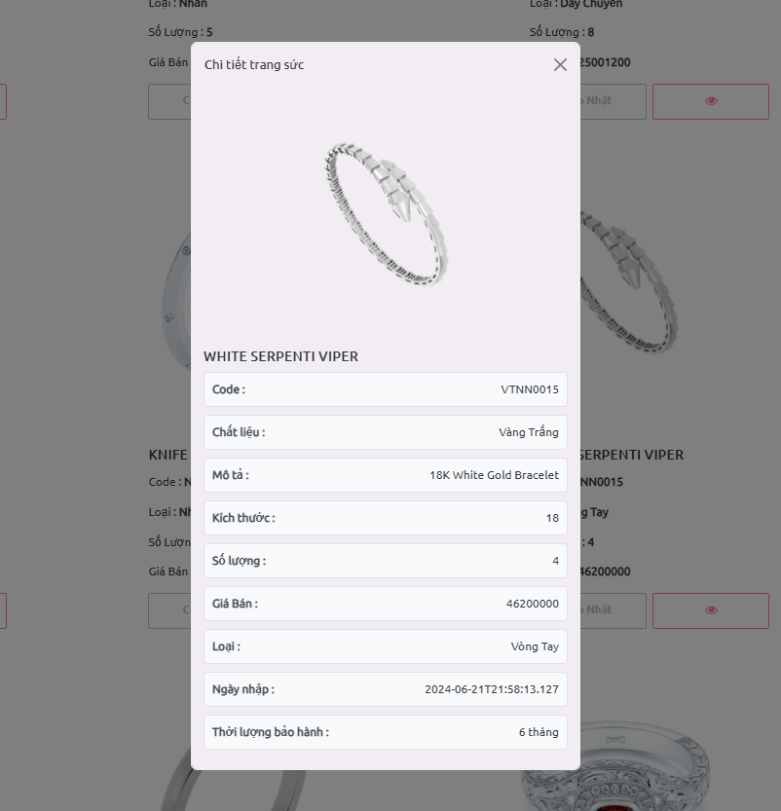

6. Manage Category

6.1. List categories

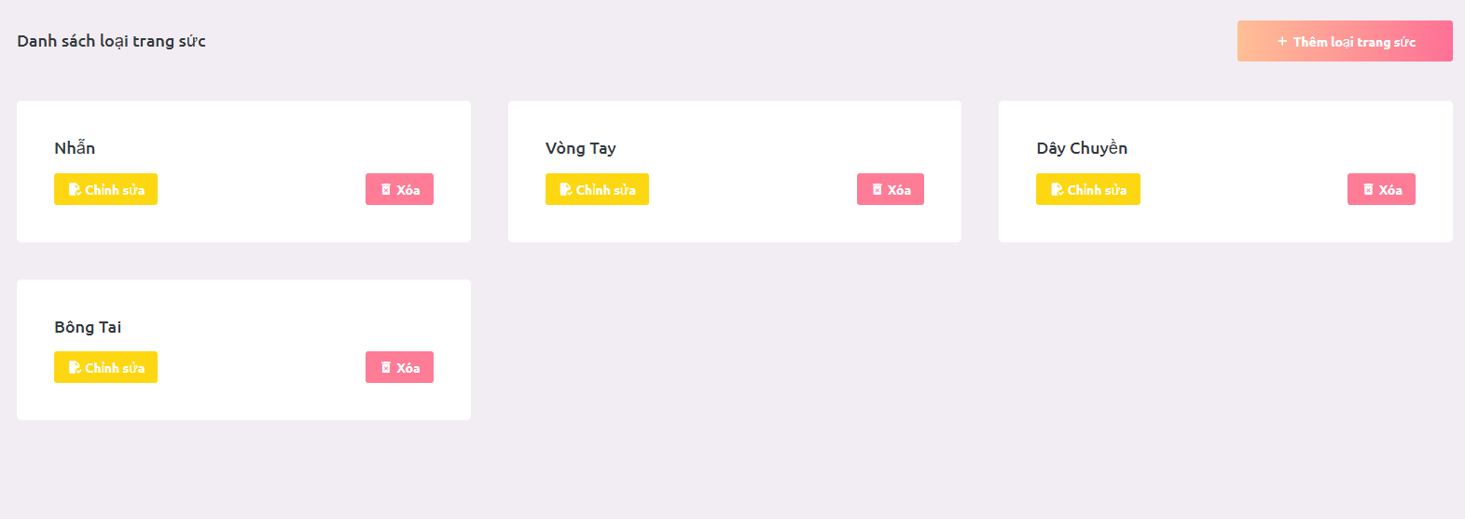

6.2. Add new category

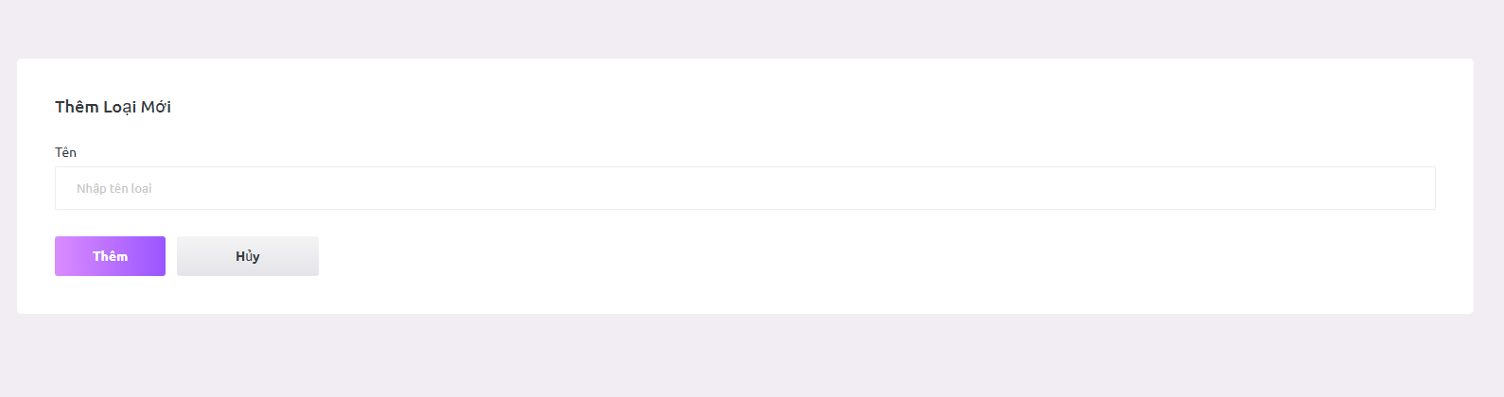

6.3. Update category

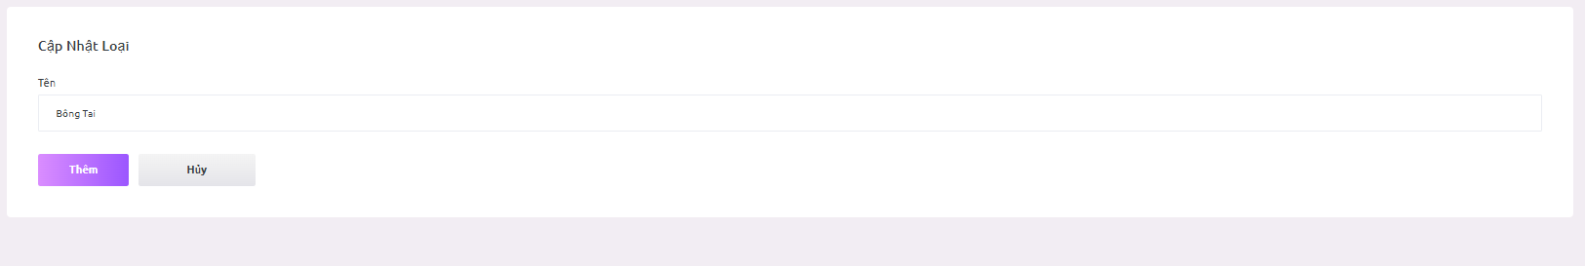

6.4. Delete category

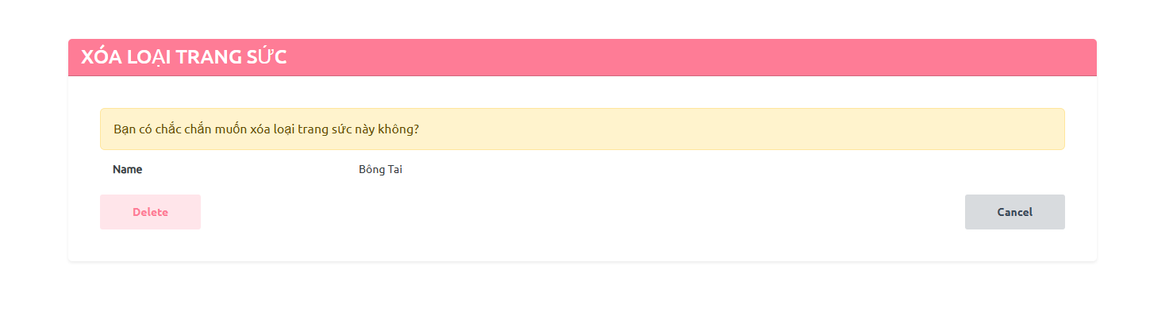

7. Manage Material

7.1. List materials

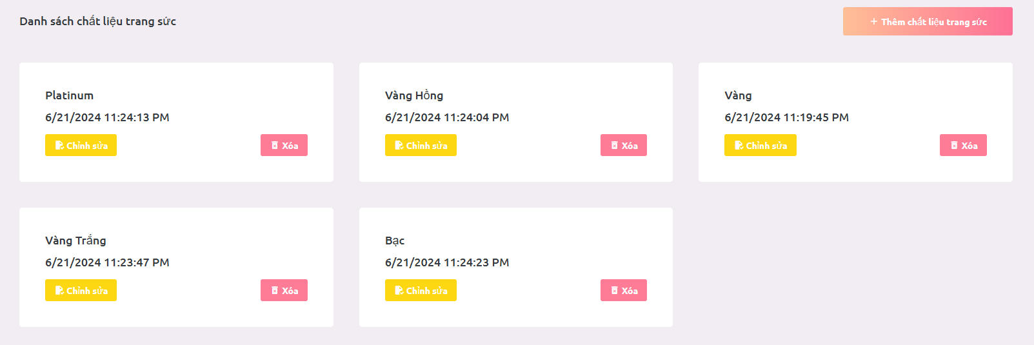

7.2. Add new material

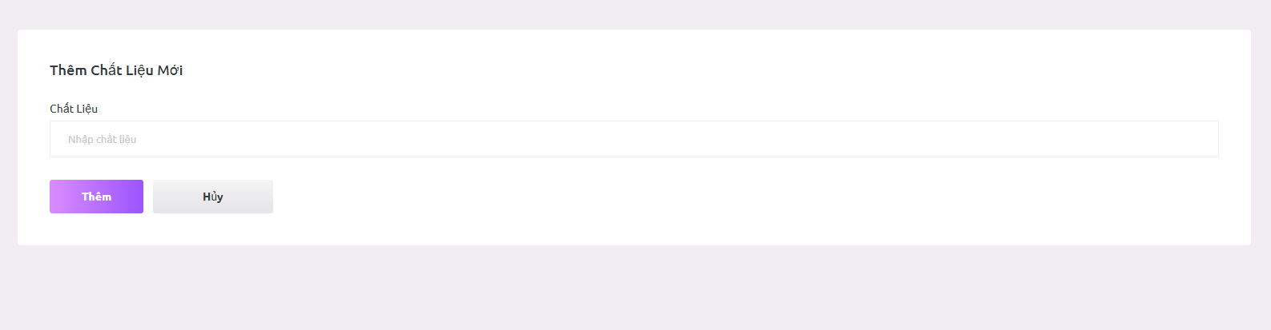

7.3. Update material

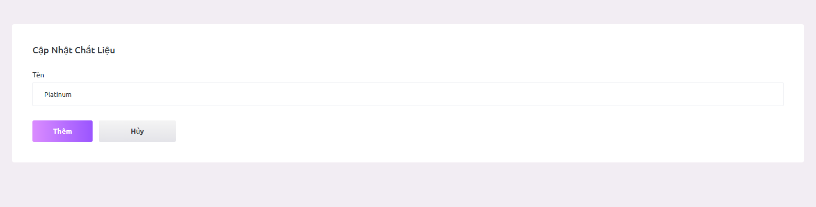

7.4. Delete material

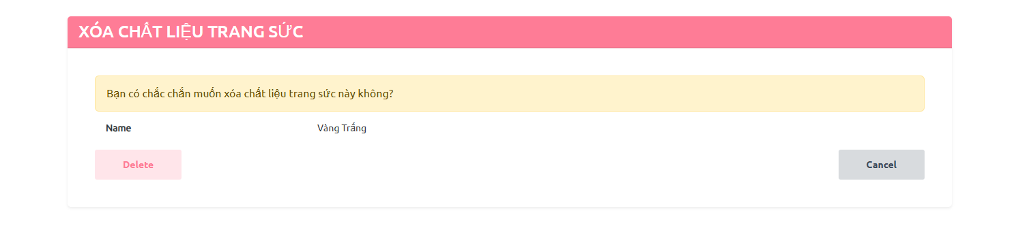

8. Manage Diamond

8.1. List diamonds

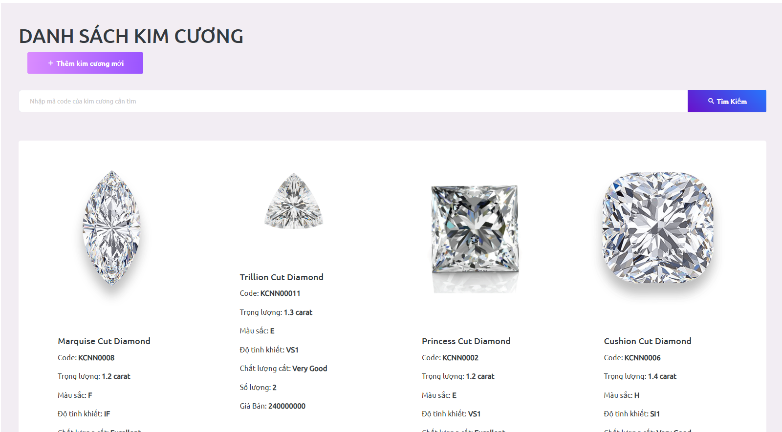

8.2. Add a new diamond

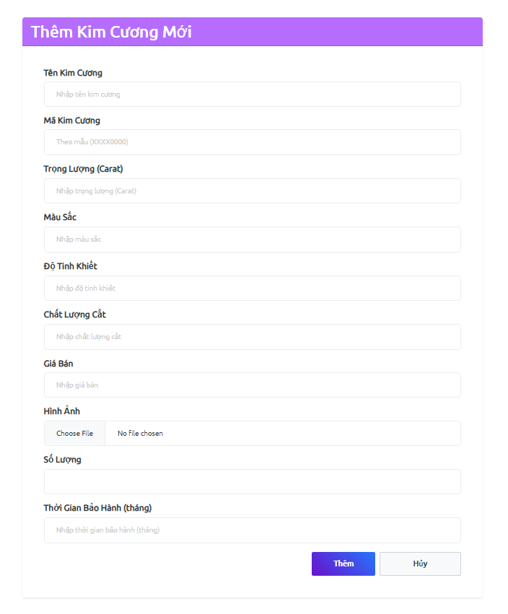

8.3. Details diamond

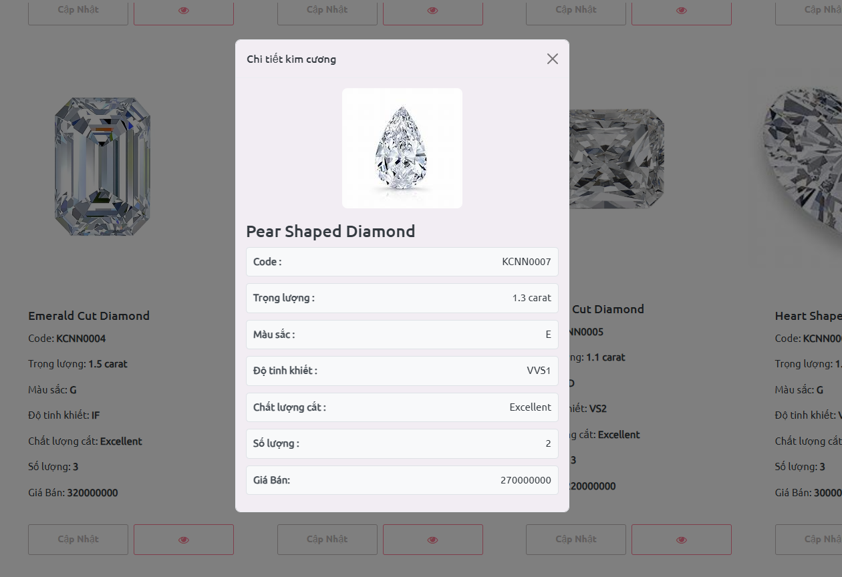

8.4. Update diamond

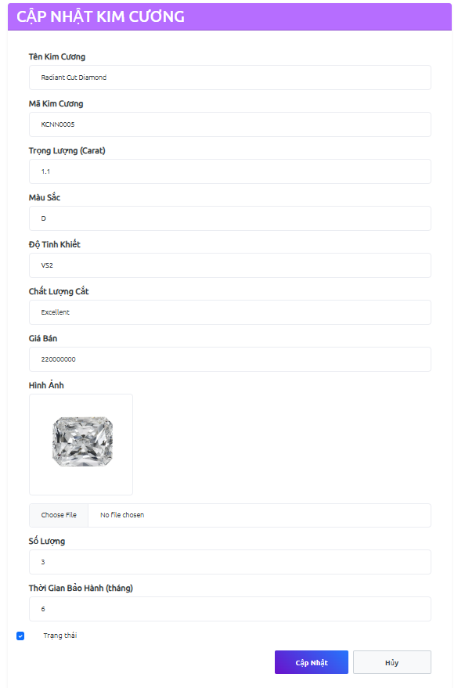

9. View List Gold Rate

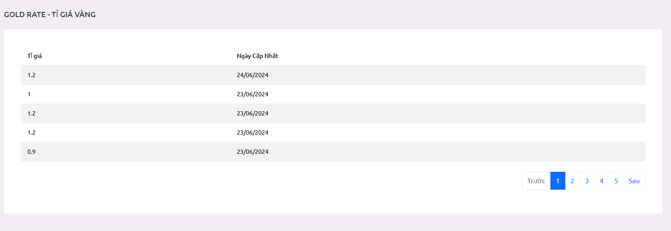

10. Manage Order

10.1 Create order

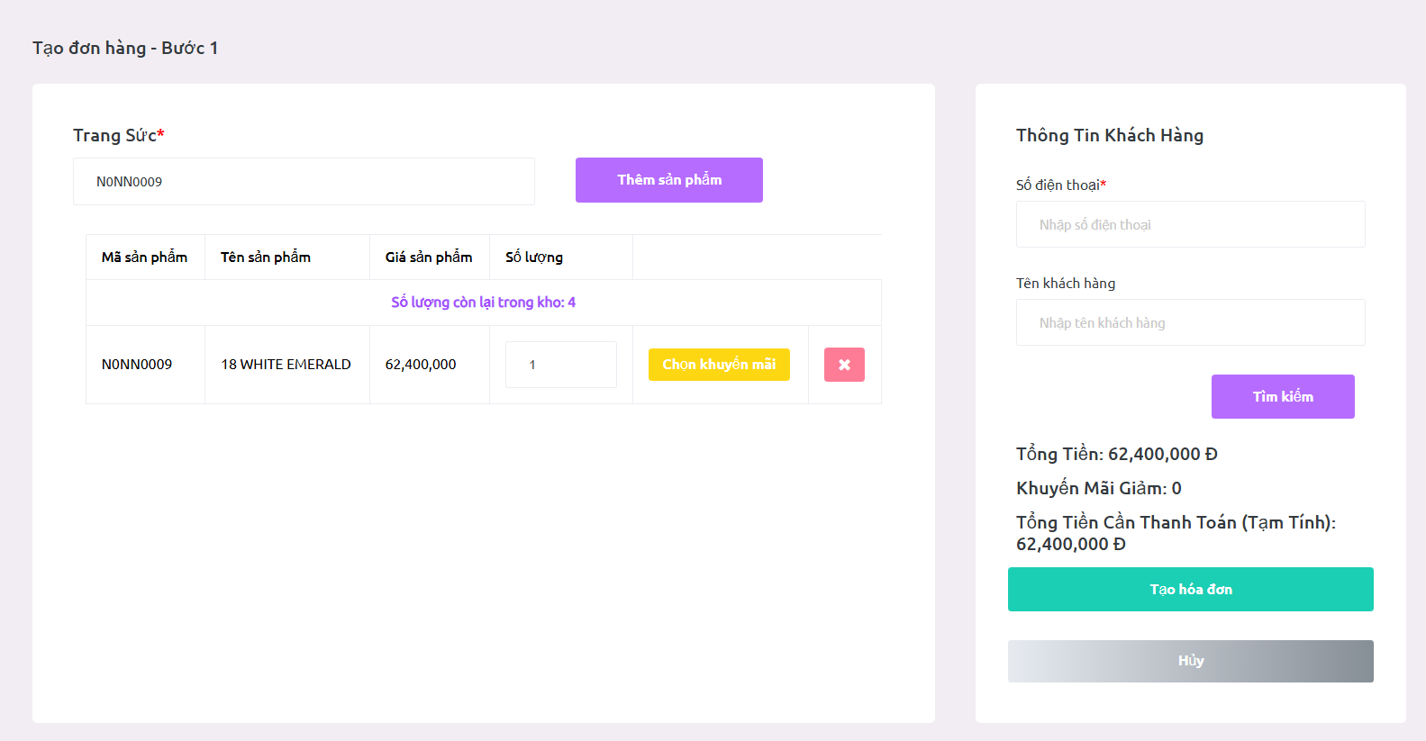

10.2 Add Process Product

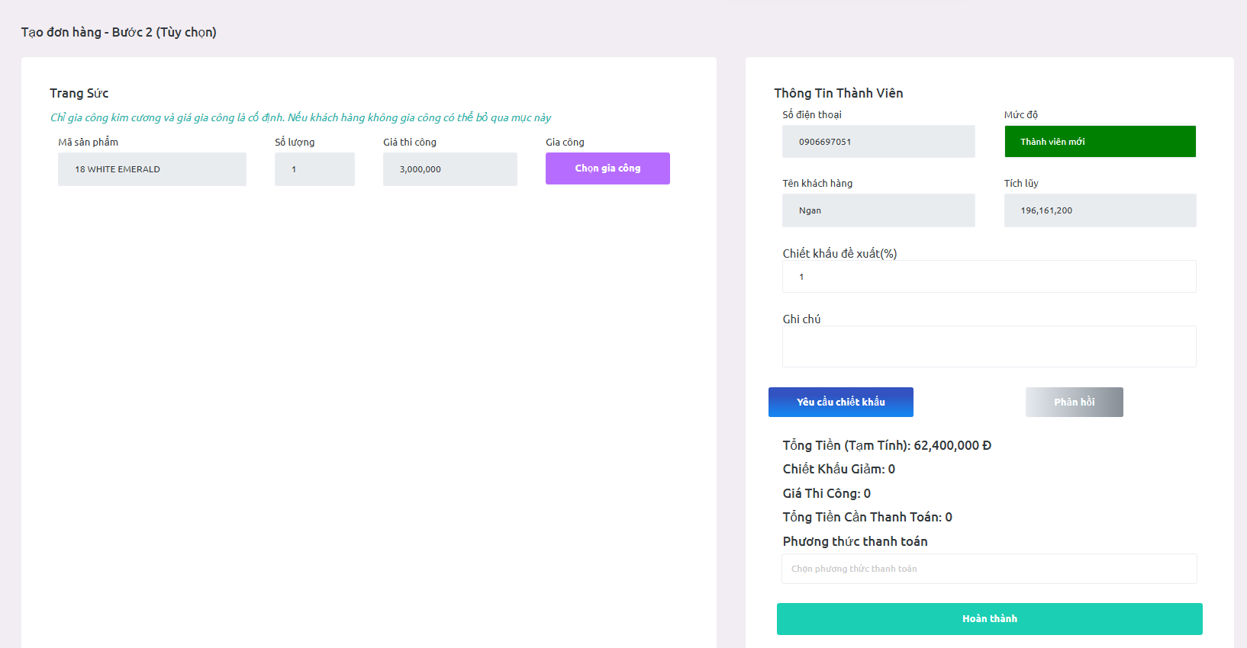

## 

10.3 List order

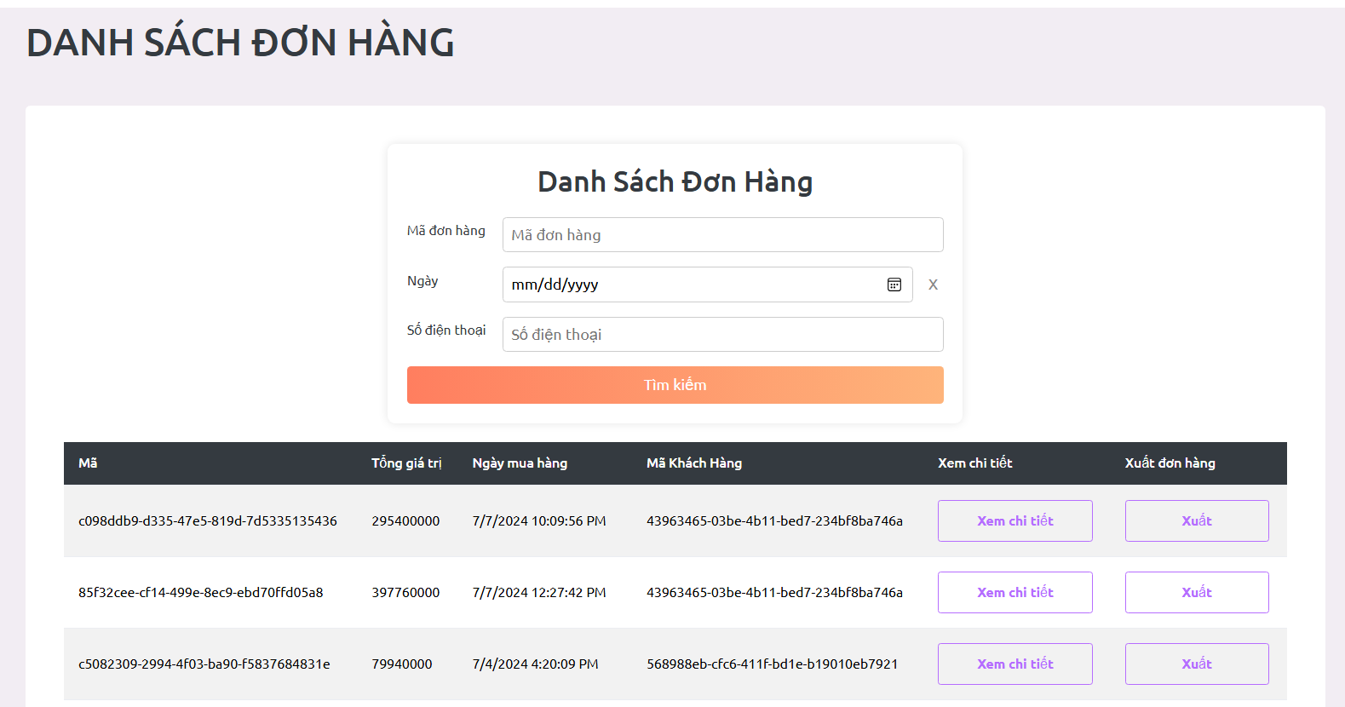

10.4 Detail order

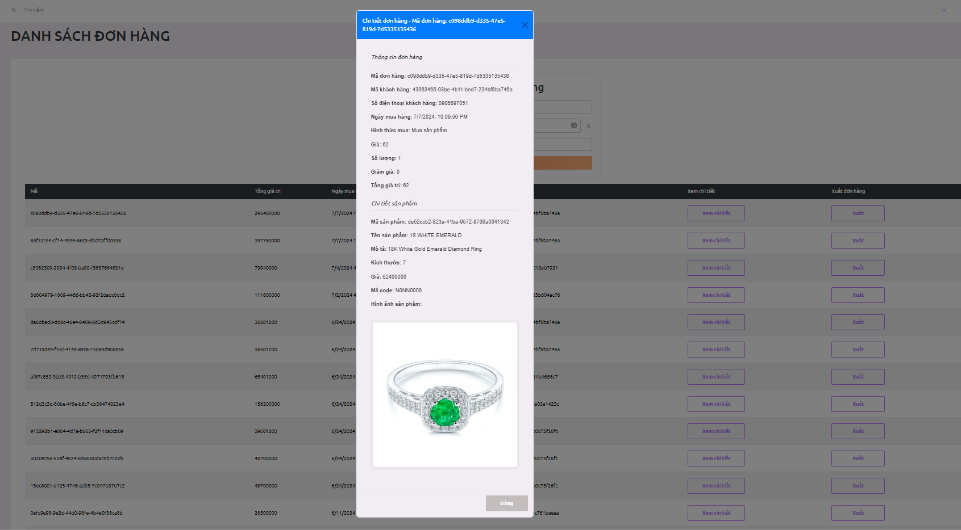

10.5 Import bill

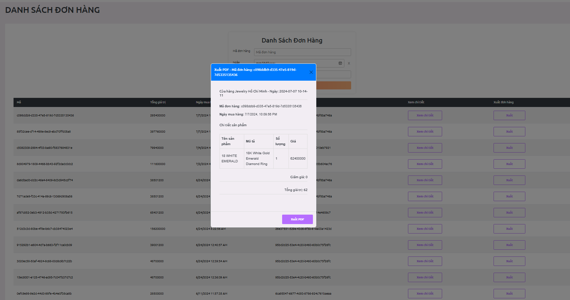

10.5 Search order

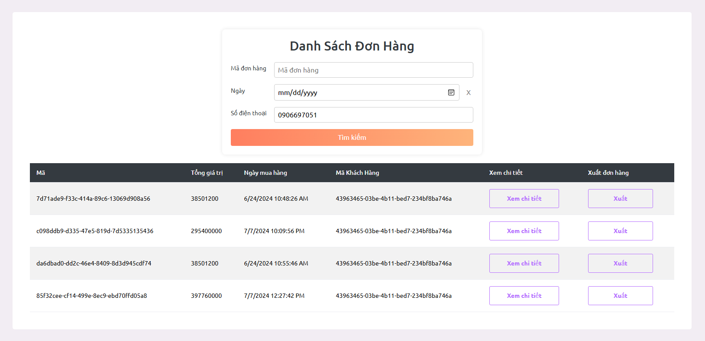

11. Manage Warranty

11.1 Create warranty

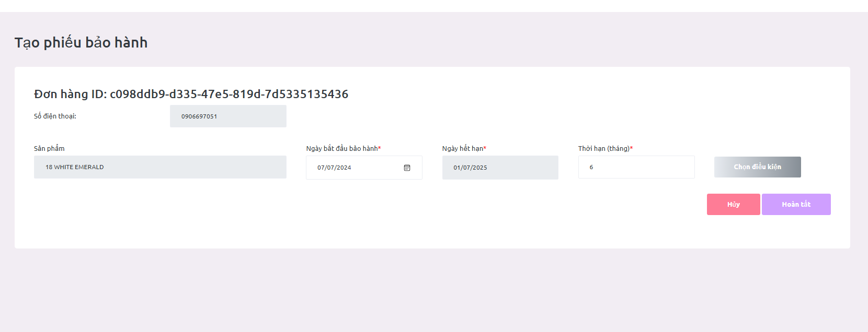

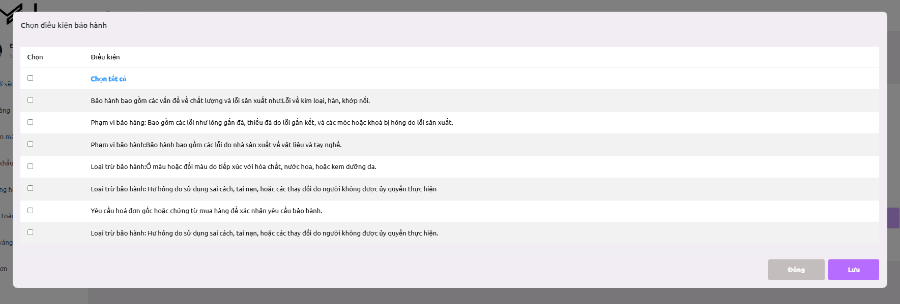

11.2 List warranty

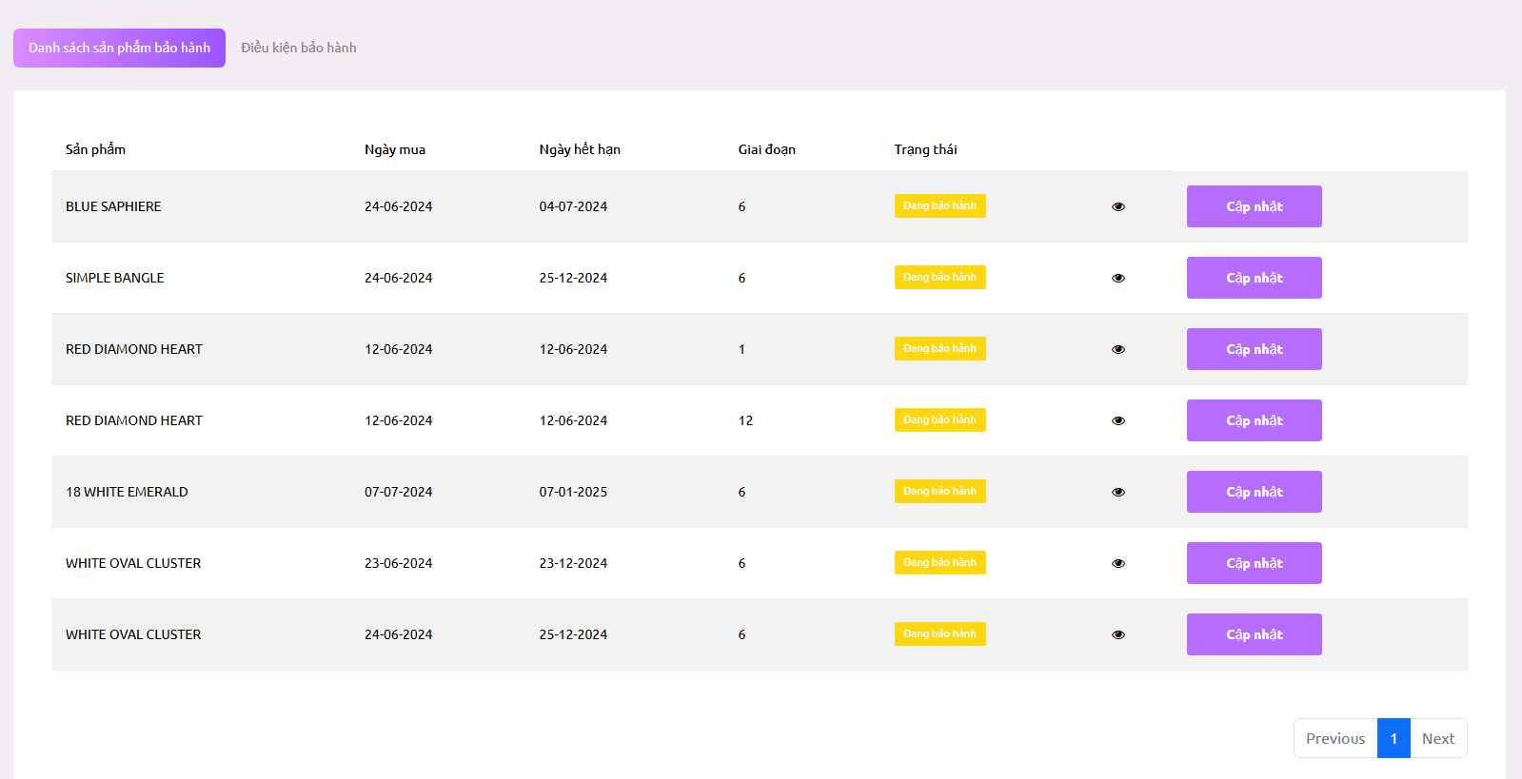

11.3 Detail warranty

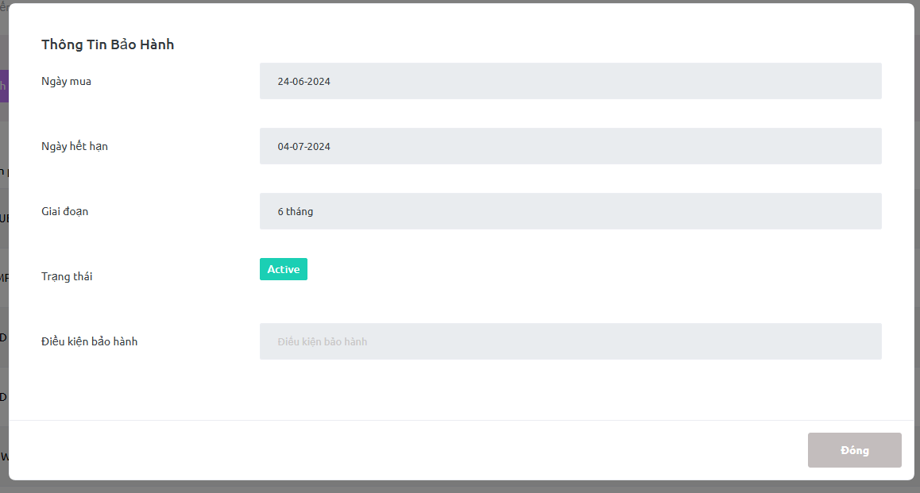

11.4 Receive warranty products from customers

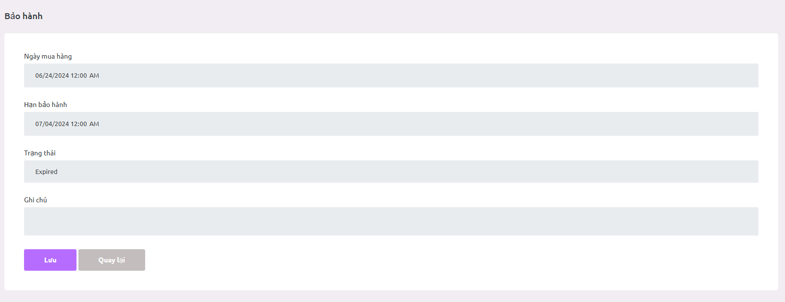

12. Manage condition warranty

12.1 List warranty

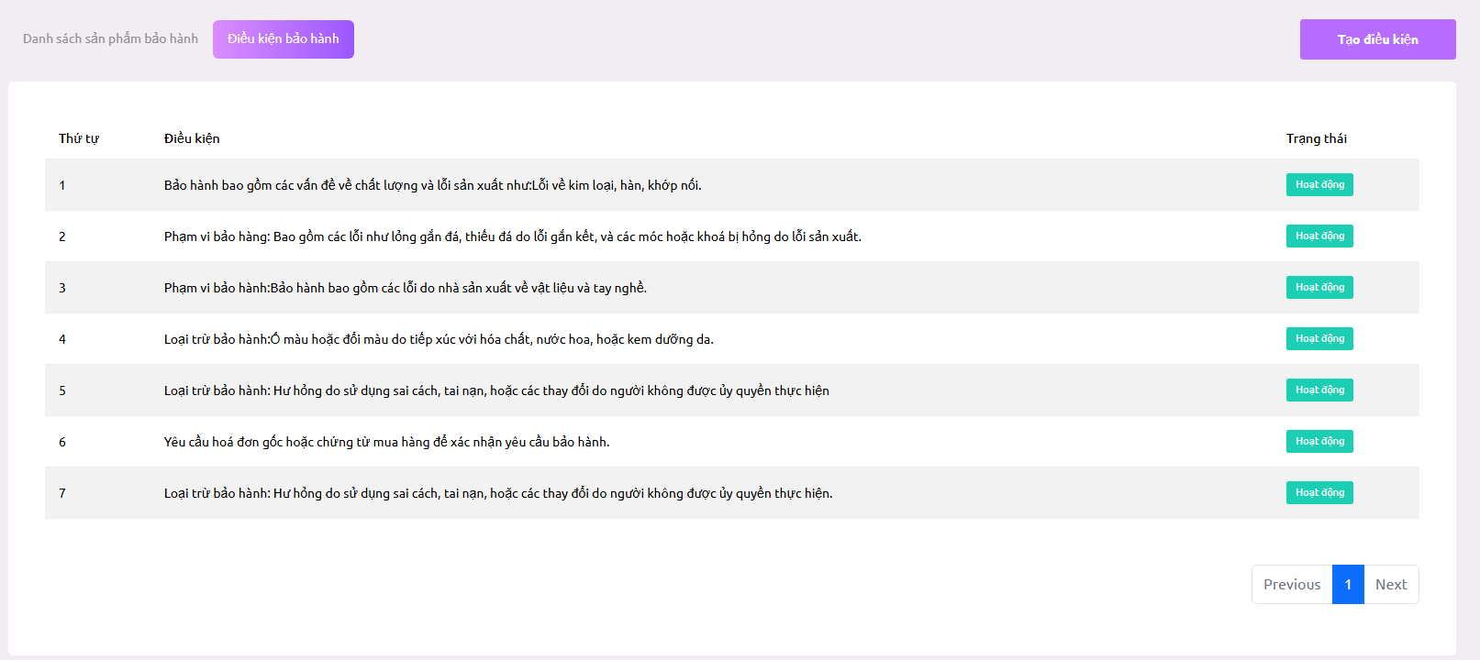

12.2 Create warranty

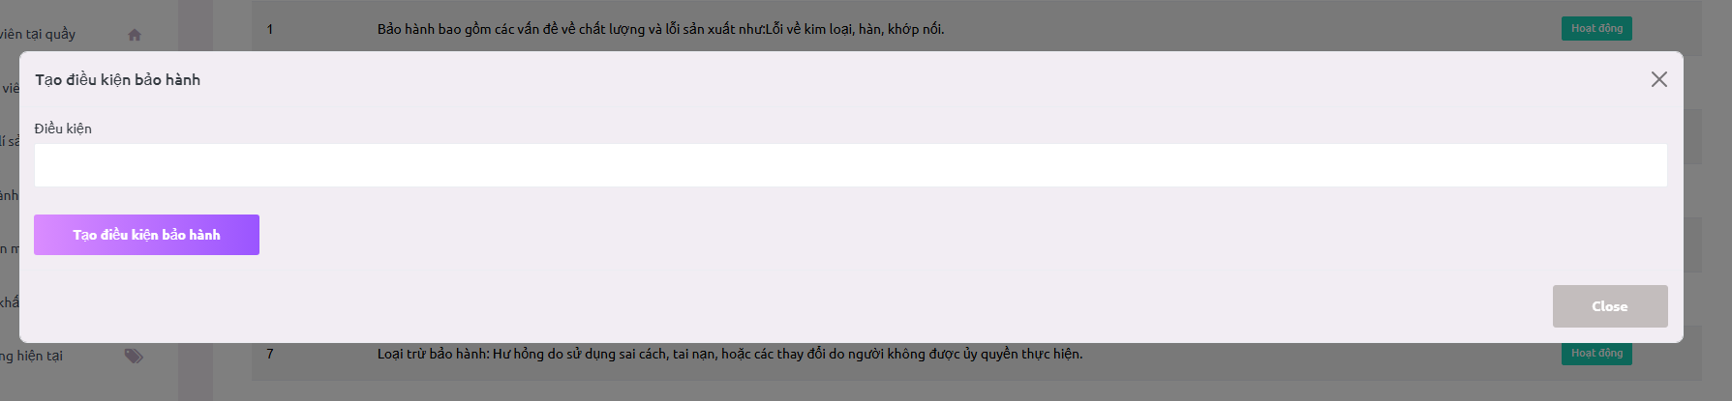

13. Manage membership

13.1 List membership

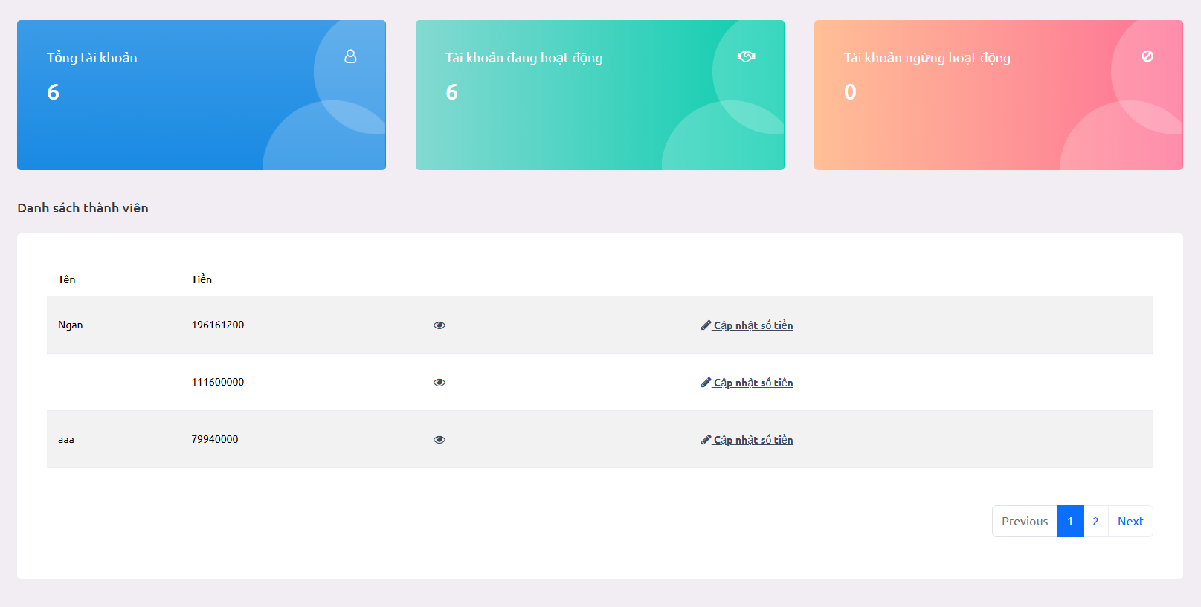

13.2 Detail membership

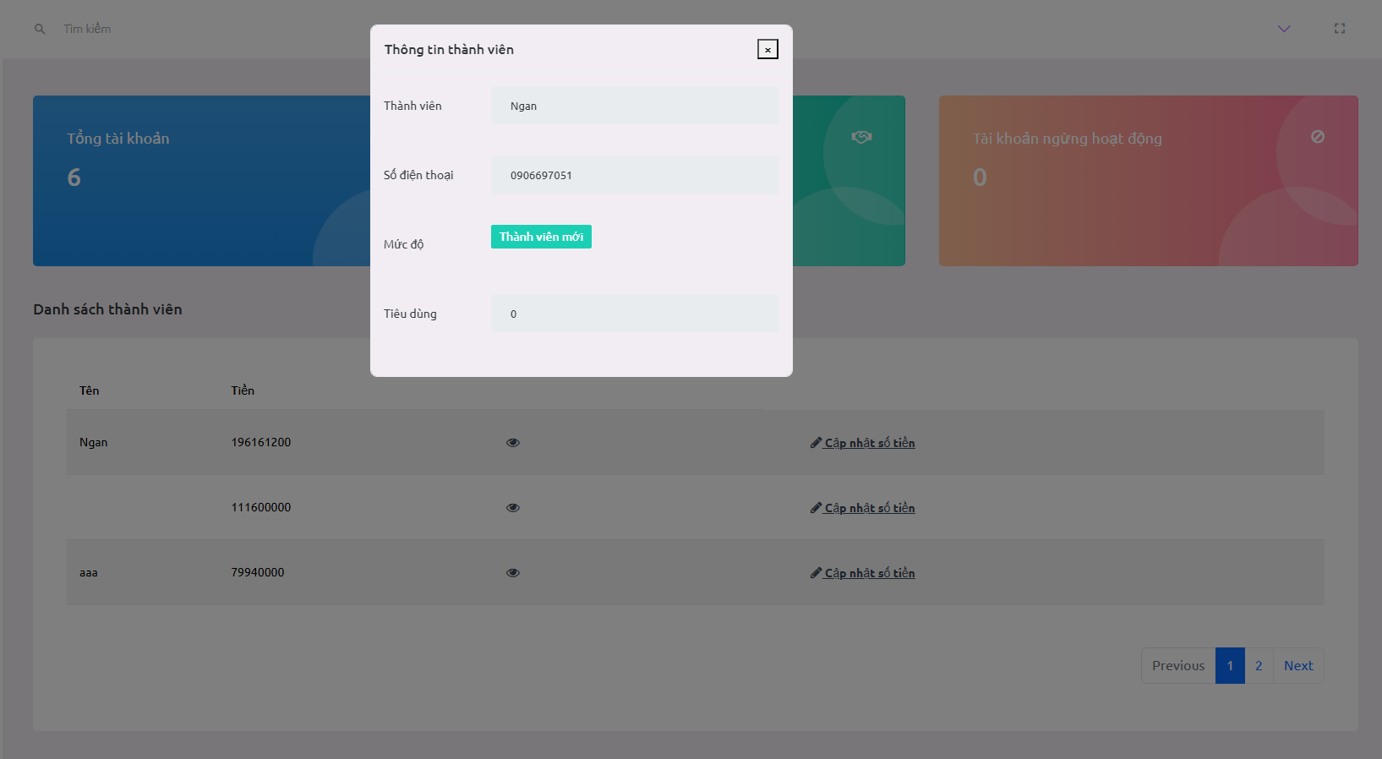

14. Manage Promotion

14.1. List promotions

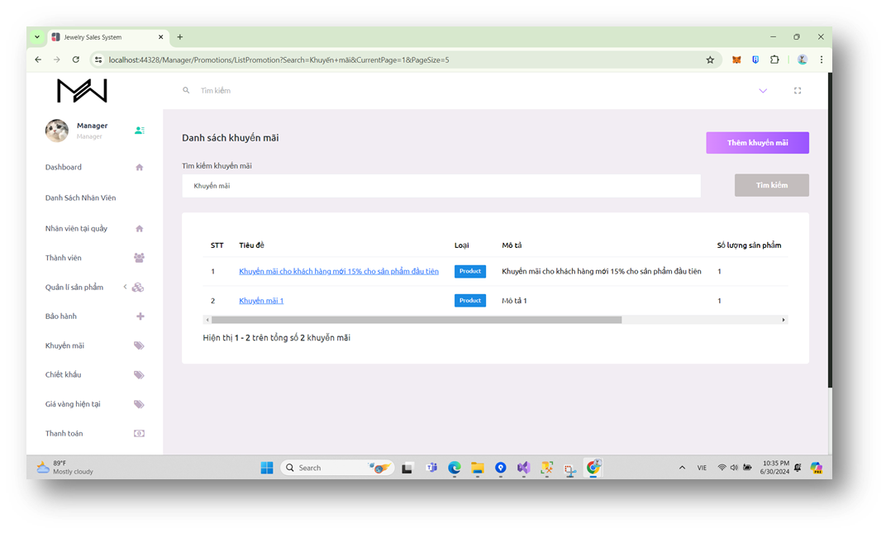

14.2. Add new promotion

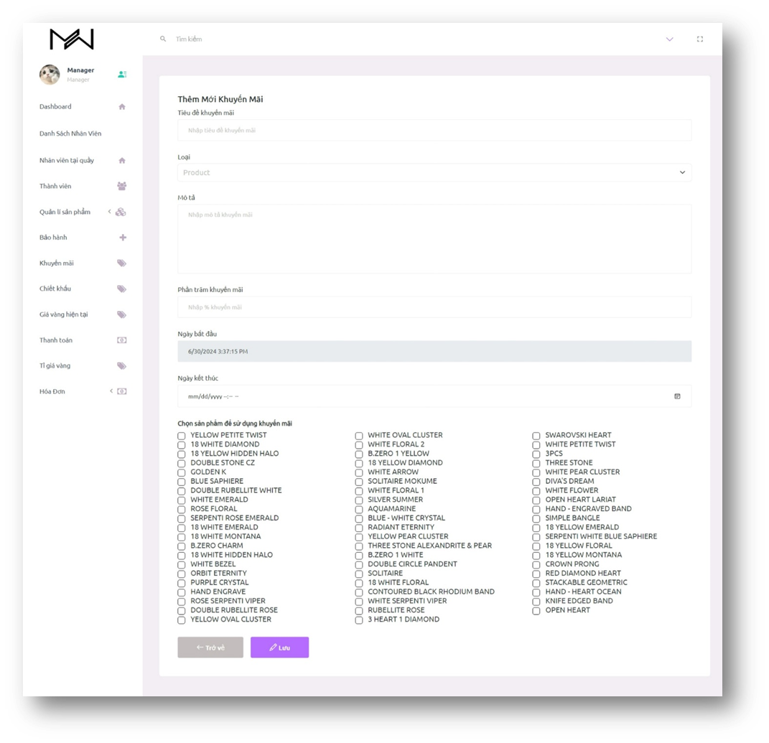

14.3. Details promotion

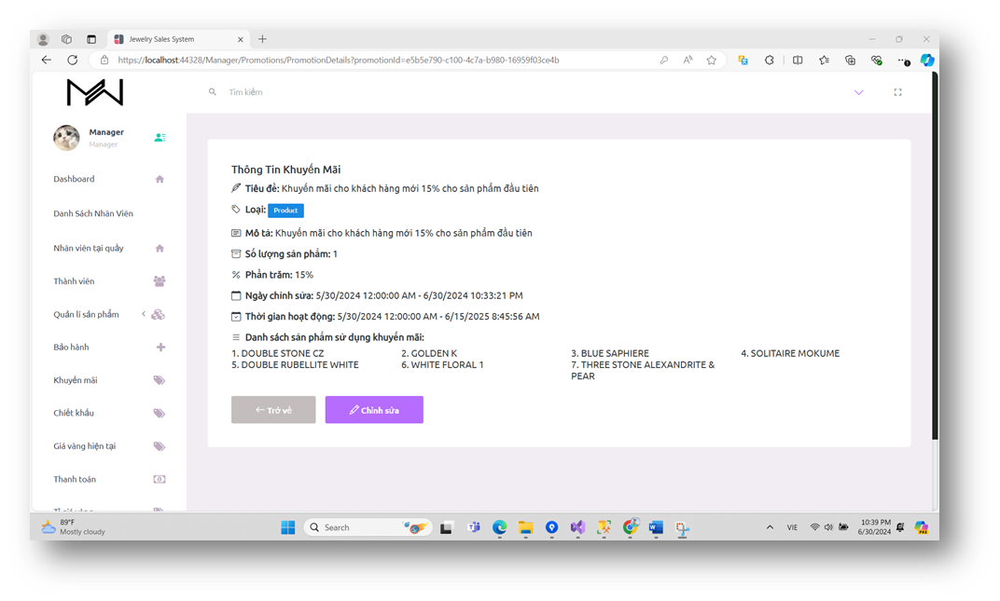

14.4. Update promotion

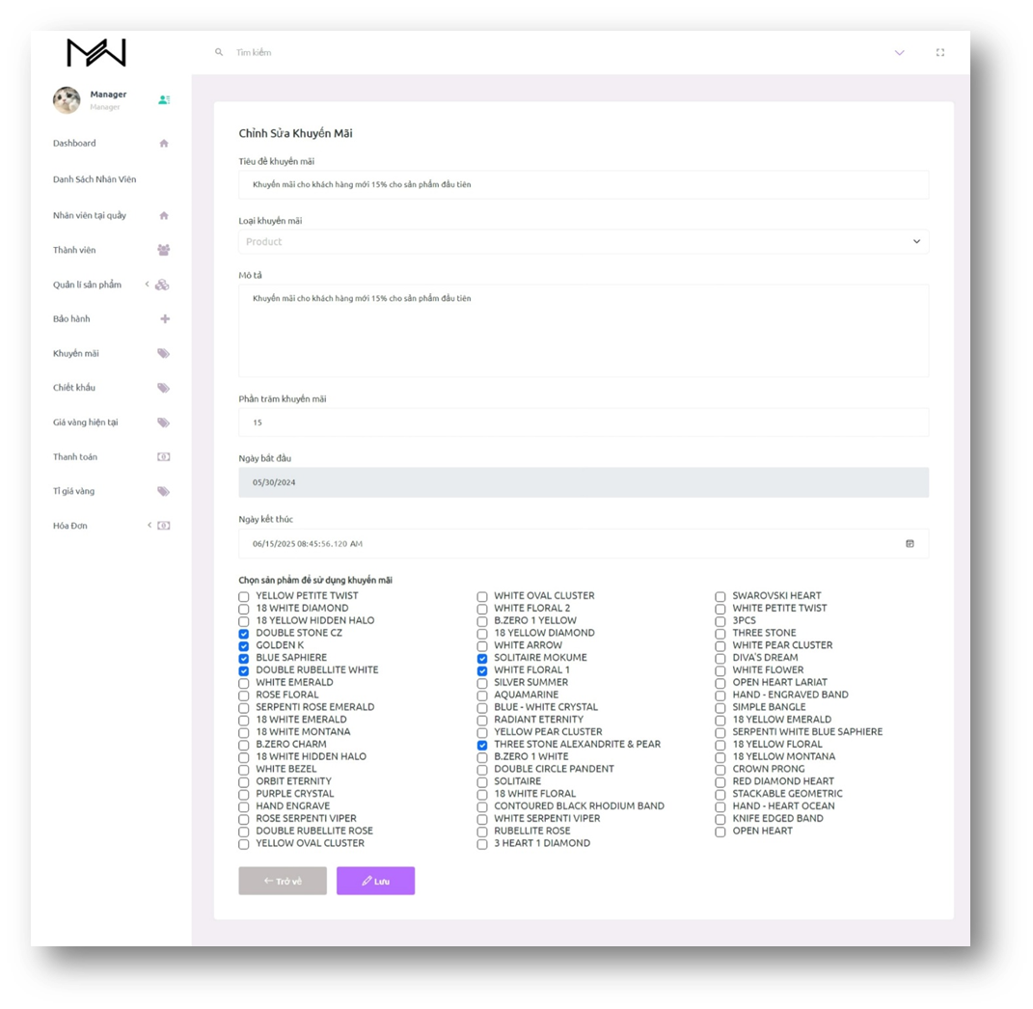

15. Manage Discount

15.1. List discounts

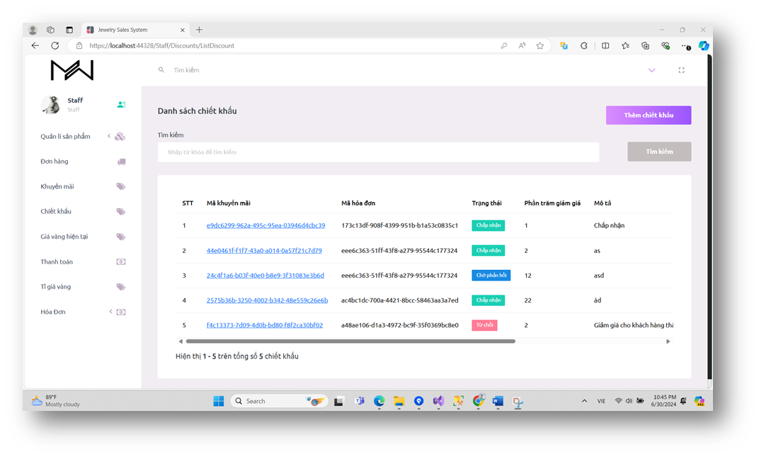

15.2. Details discount

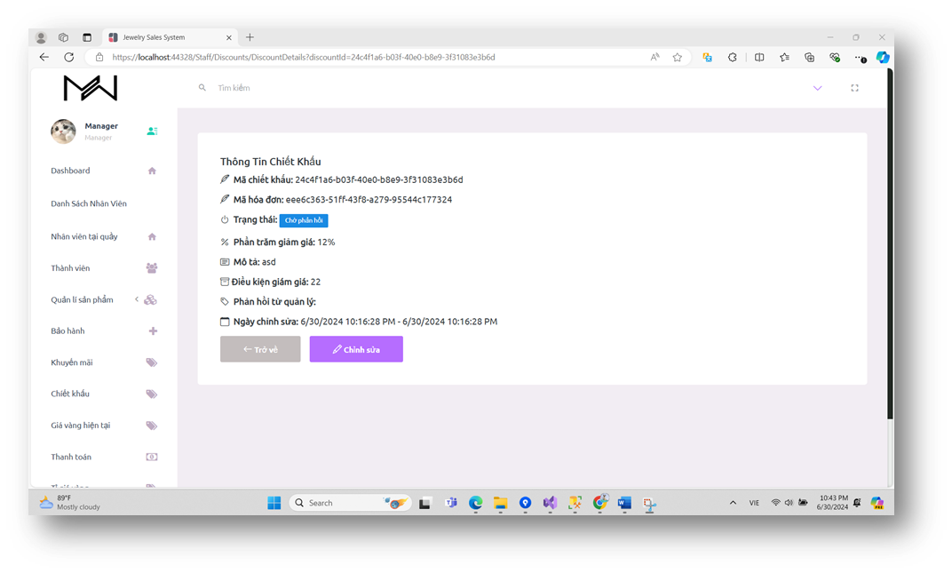

15.3. Approve discount

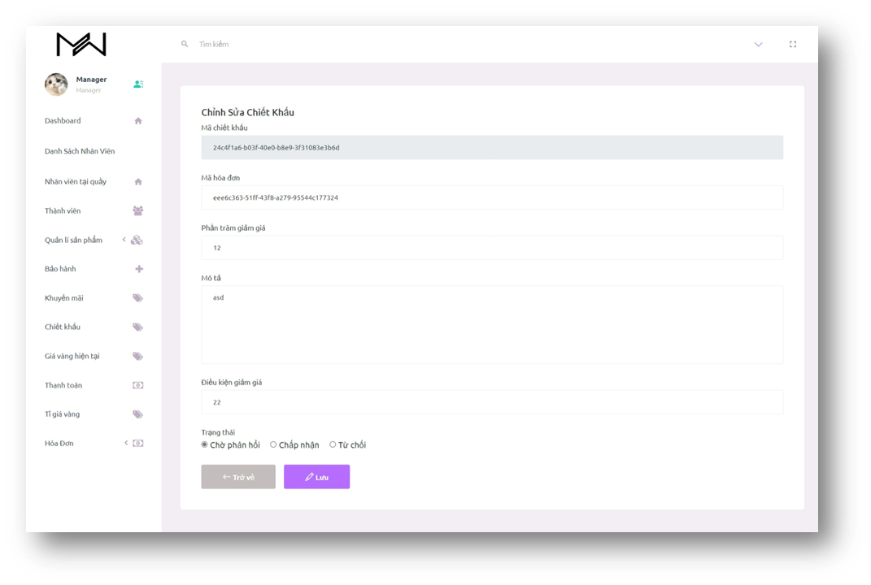

15.4. Update discount

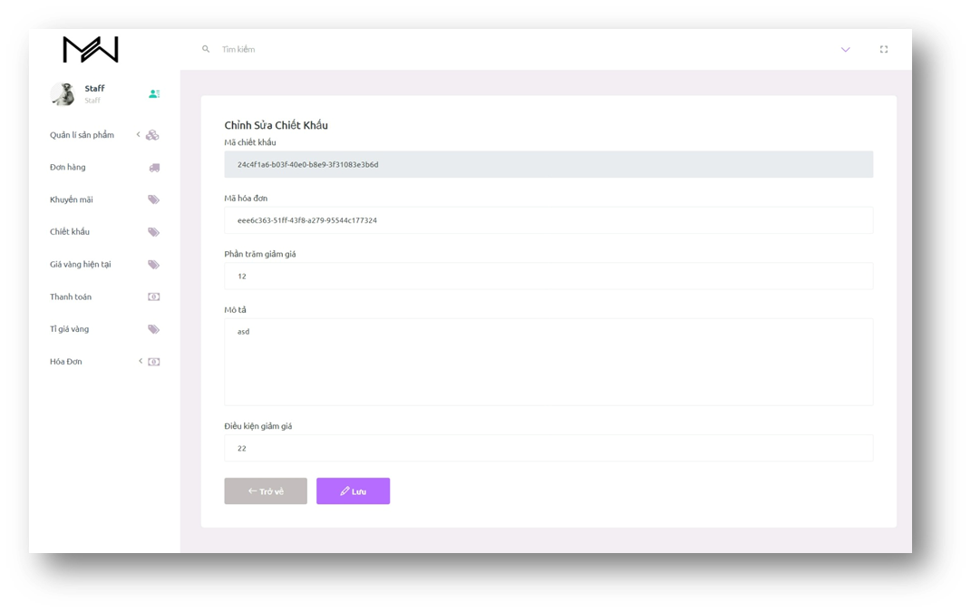

16. Manage Transaction

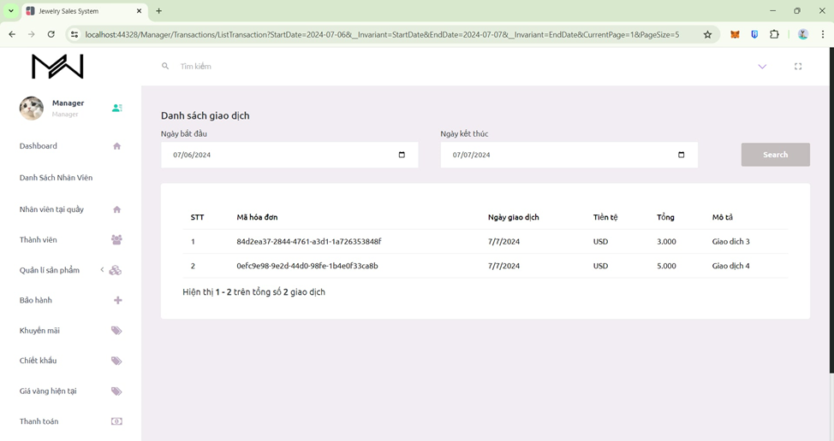

17. Dashboard

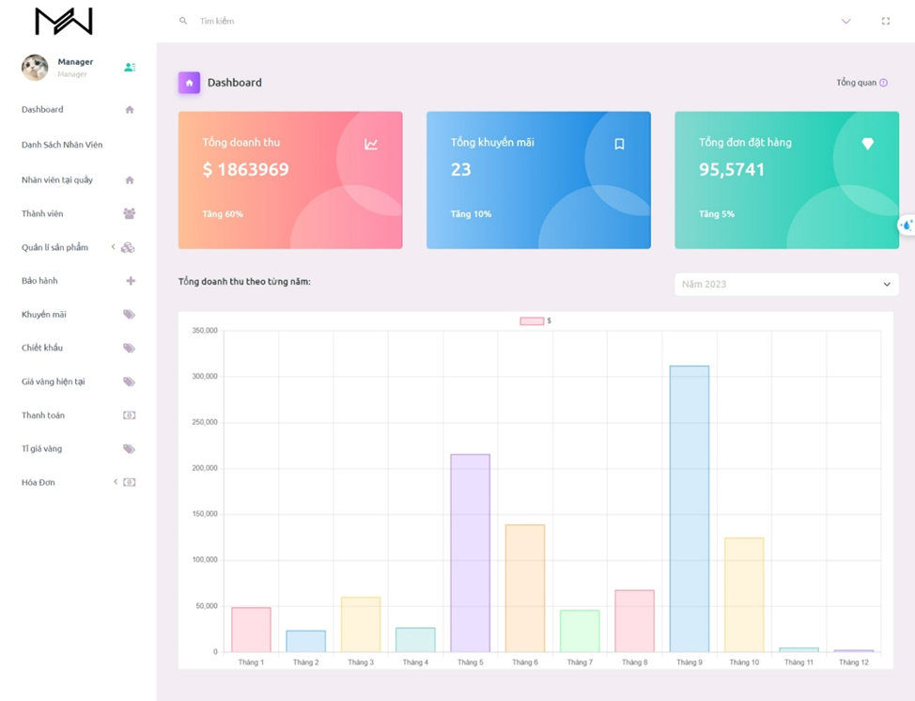

18. Purchasing Jewelry

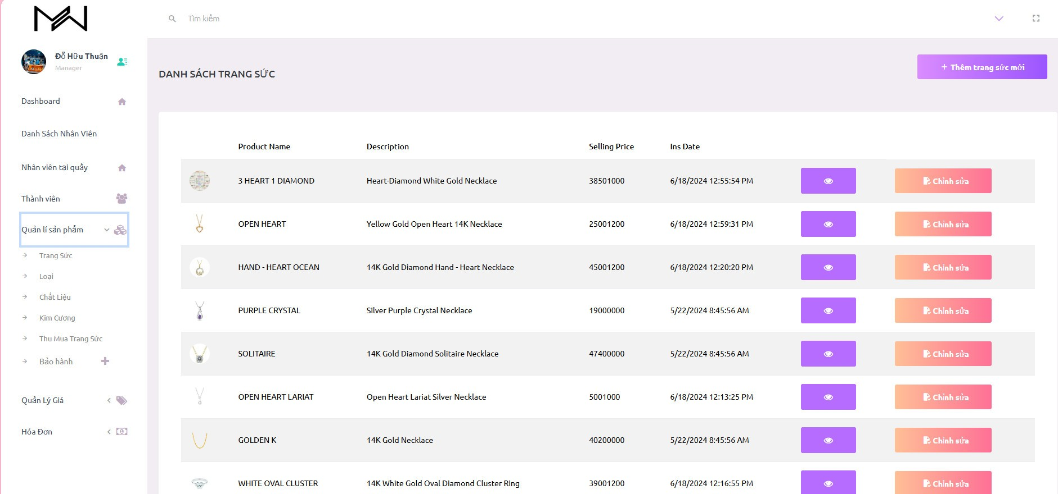

19. Update Purchasing Jewelry

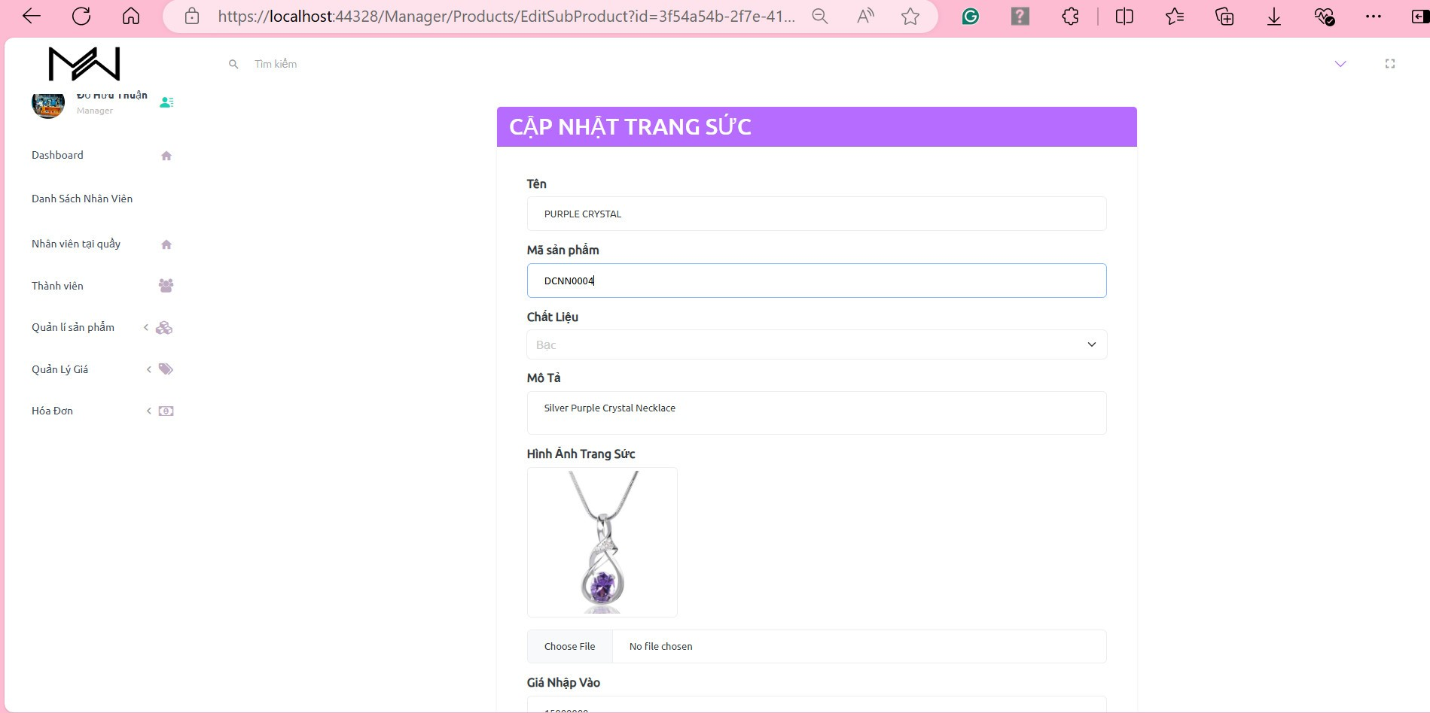

20. Create Purchasing Jewelry

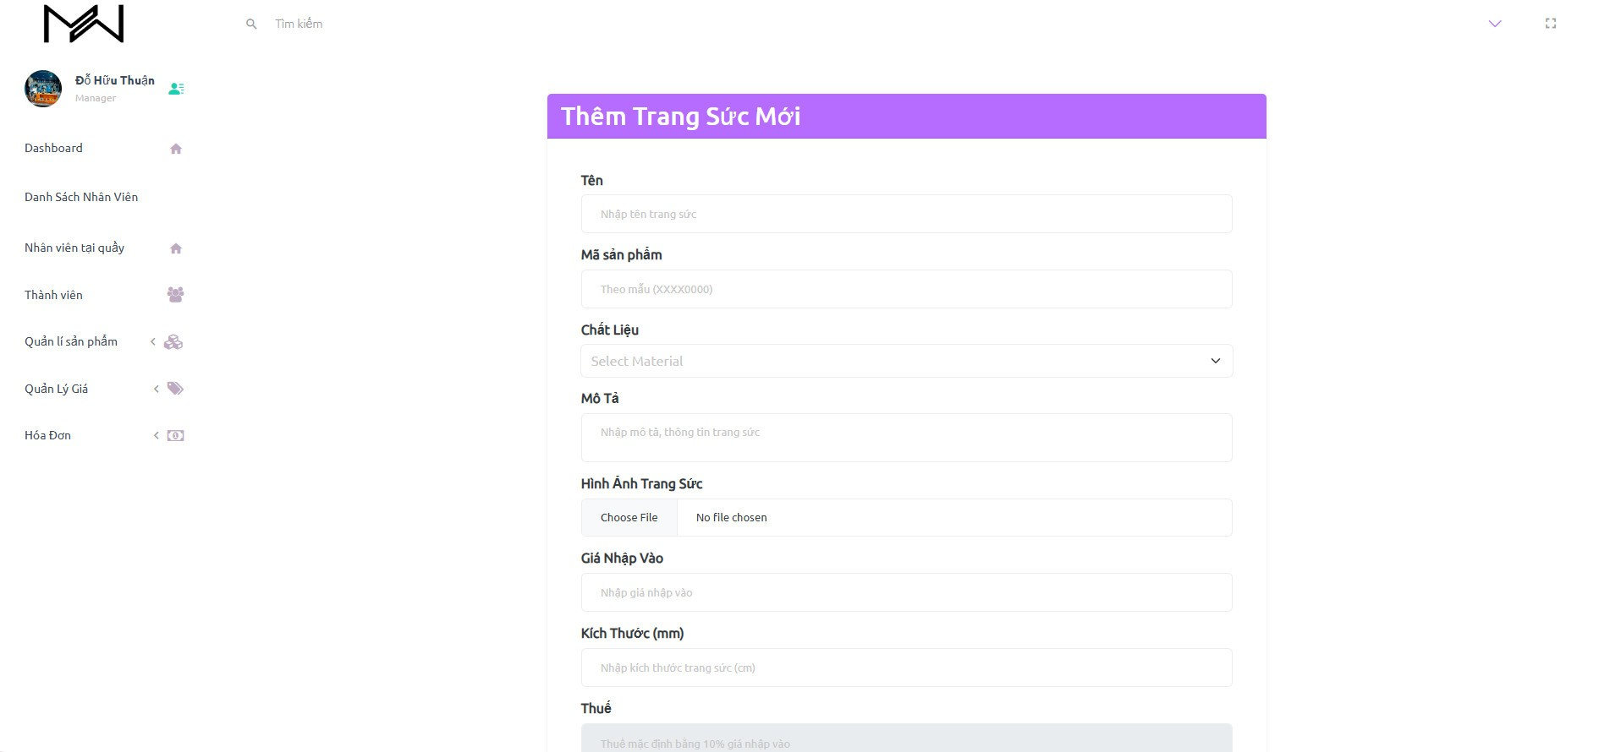

21. Manage Diamond Price

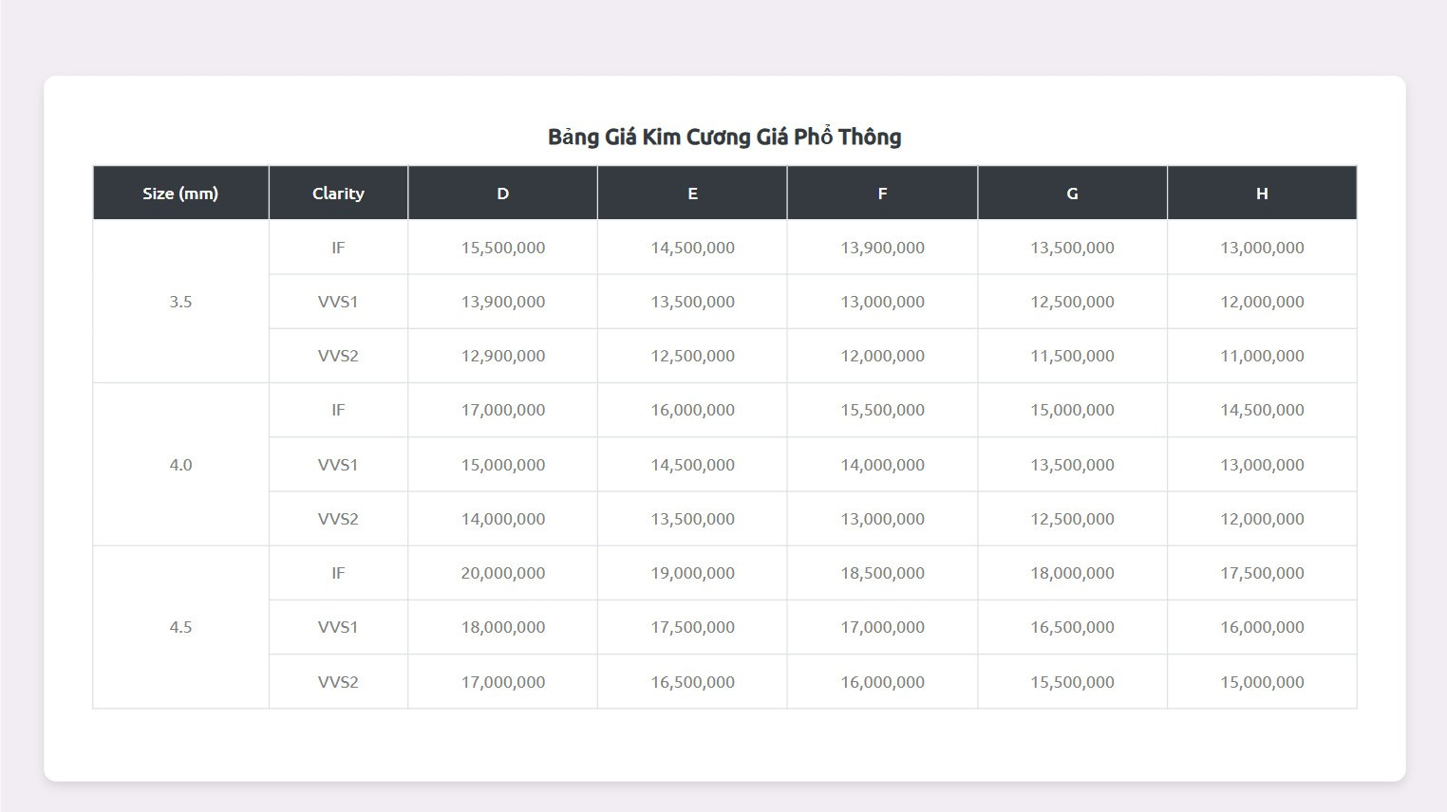

21. Set Purchasing Price

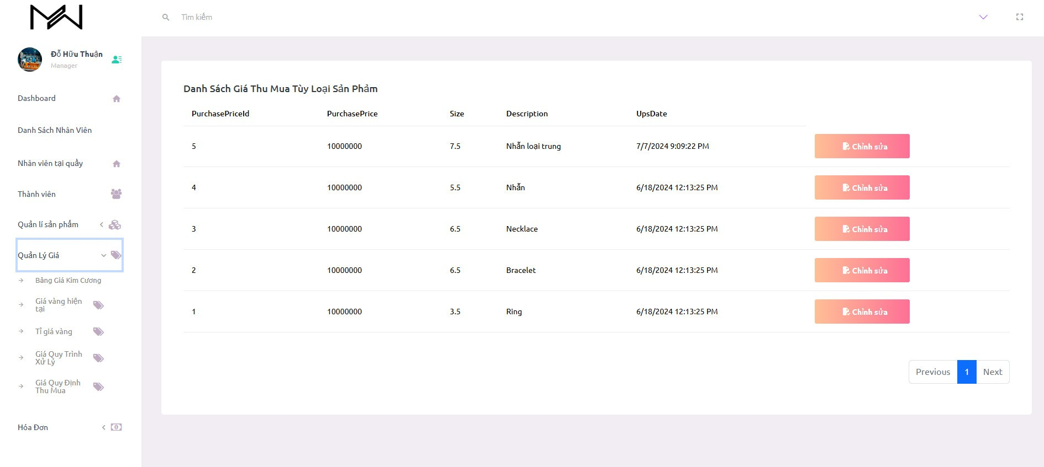

22. Set Processing Price

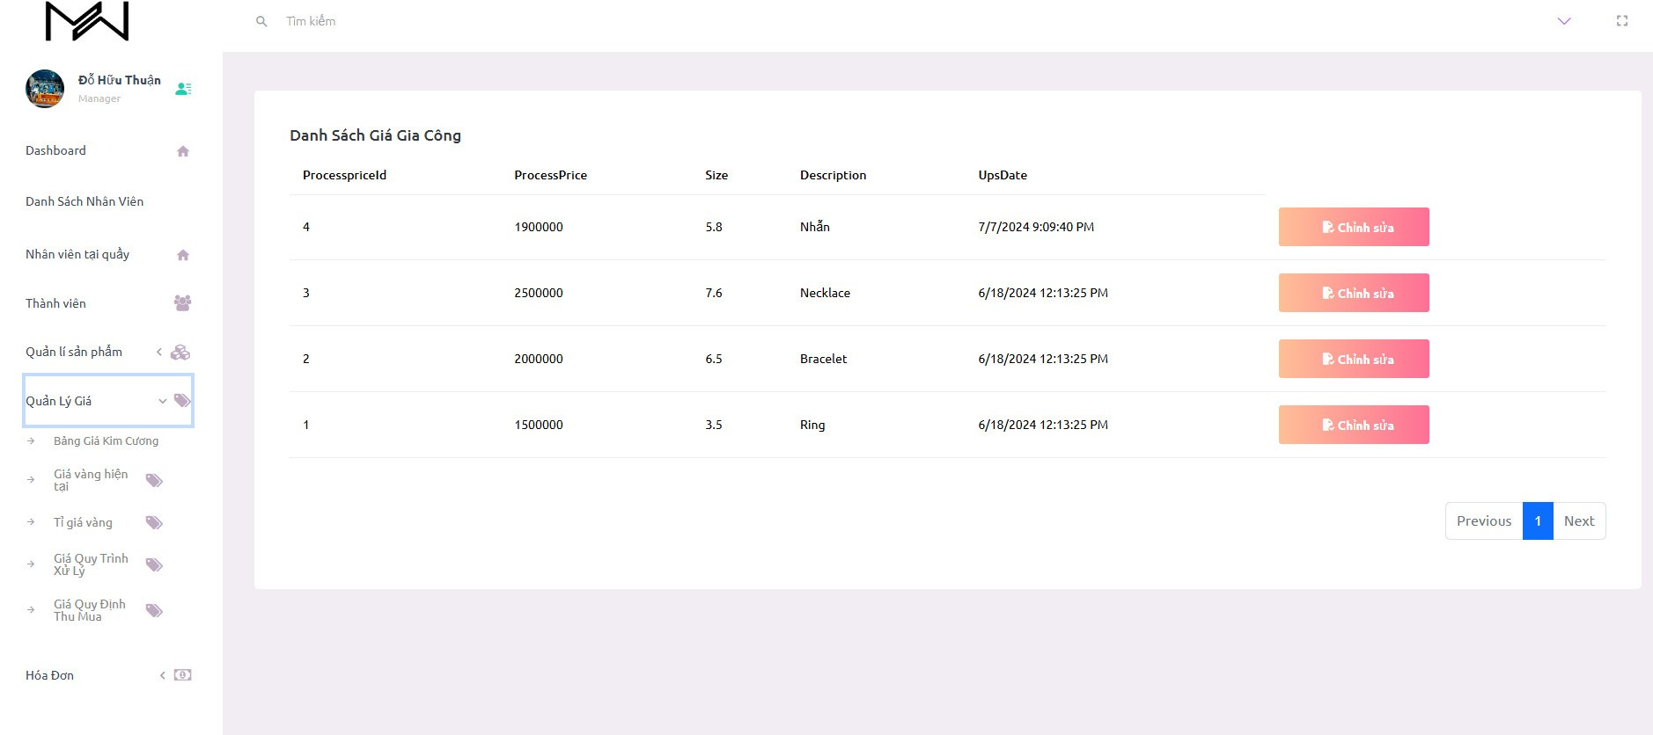

23. Payment

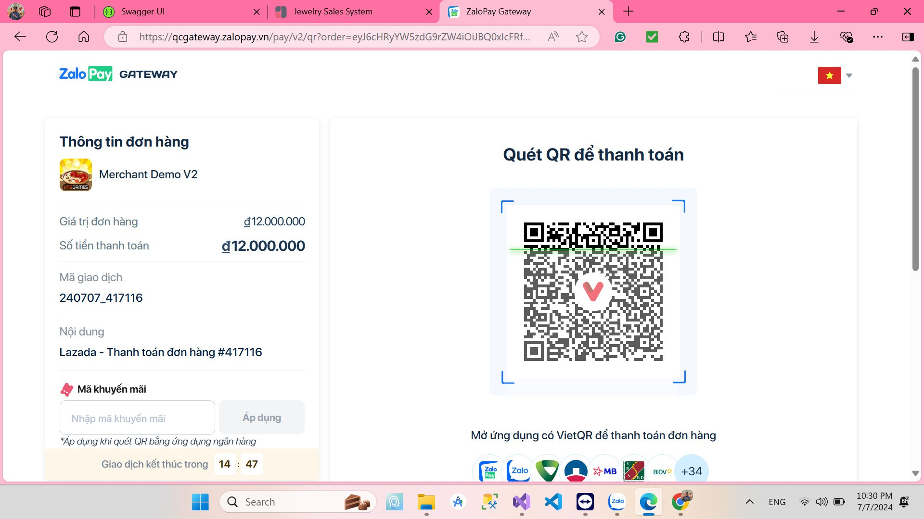

# **Business Rules**

|  |  |
| --- | --- |
| **ID** | **Rule Definition** |
| BR-01 | Only promotion for one products. |
| BR-02 | Discount apply for a bills (all amount) |